UNITED STATES

SECURITIES AND EXCHANGE COMMISSION
Washington, D.C. 20549

FORM 8-K

CURRENT REPORT

Pursuant to Section 13 OR 15(d) of the

Securities Exchange Act of 1934

Date of Report (Date of earliest event reported): January 1, 2026

TMC THE METALS COMPANY INC.

(Exact name of registrant as specified in its charter)

British Columbia, Canada | 001-39281 | Not Applicable
(State or other jurisdiction of | (Commission File Number) | (IRS Employer
incorporation) |  | Identification No.)
1111 West Hastings Street, 15th Floor
Vancouver, British Columbia |  | V6E 2J3
(Address of principal executive |  | (Zip Code)
offices)

Registrant’s telephone number, including area code: (888) 458-3420

Not applicable

(Former name or former address, if changed since last report)

Check the appropriate box below if the Form 8-K filing is intended to simultaneously satisfy the filing obligation of the registrant under any of the following provisions:

- Written communications pursuant to Rule 425 under the Securities Act (17 CFR 230.425)

- Soliciting material pursuant to Rule 14a-12 under the Exchange Act (17 CFR 240.14a-12)

- Pre-commencement communications pursuant to Rule 14d-2(b) under the Exchange Act (17 CFR 240.14d-2(b))

- Pre-commencement communications pursuant to Rule 13e-4(c) under the Exchange Act (17 CFR 240.13e-4(c)) Securities registered pursuant to Section 12(b) of the Act:
 |  |  |  | Name of each exchange on
Title of each class |  | Trading Symbol(s) |  | which registered
TMC Common Shares without par value |  | TMC |  | The Nasdaq Stock Market LLC
Redeemable warrants, each whole warrant exercisable |  | TMCWW |  | The Nasdaq Stock Market LLC
for one TMC Common Share, each at an exercise price
of $11.50 per share

Indicate by check mark whether the registrant is an emerging growth company as defined in Rule 405 of the Securities Act of 1933 (§230.405 of this chapter) or Rule 12b-2 of the Securities Exchange Act of 1934 (§240.12b-2 of this chapter).

Emerging growth company ☐

If an emerging growth company, indicate by check mark if the registrant has elected not to use the extended transition period for complying with any new or revised financial accounting standards provided pursuant to Section 13(a) of the Exchange Act. ☐

Item 5.03 Amendment to Articles of Incorporation or Bylaws; Change in Fiscal Year.

The information set forth in Item 8.01 is incorporated into this Item 5.03 by reference.

Item 8.01. Other Information.

On January 1, 2026, TMC the metals company Inc. (the “Company”) completed a vertical short-form amalgamation pursuant to the Business Corporations Act (British Columbia) (the “BCABC”) with its previously wholly owned subsidiary, DeepGreen Metals ULC (“DGM”), which was an intermediate holding company with no operations, in order to simplify the corporate structure of the Company. Pursuant to the amalgamation, (a) the Company is a continuing entity with no changes to its share capital, outstanding warrants to purchase common shares and outstanding equity incentive awards and (b) all of the issued and outstanding shares of DGM have been cancelled and the assets and liabilities of DGM have been assumed into the Company for no consideration.

There will be no changes to the Company’s business or operations as a result of the amalgamation.

In connection with the amalgamation, the Company was issued a Certificate of Amalgamation effective as of January 1, 2026 under the BCABC which includes the continuation of the Company’s Notice of Articles and Articles.

Item 9.01. Financial Statements and Exhibits.

(d) Exhibits

 |  |  | Exhibit No. |  | Description
3.1 |  |  | Certificate of Amalgamation of TMC the metals company Inc., effective as of January 1, 2026.
3.2† |  |  | Notice of Articles of TMC the metals company Inc.
3.3 |  |  | Articles of TMC the metals company Inc.
104 |  |  | Cover Page Interactive Data File (embedded within the Inline XBRL document)

† Certain personally identifiable information has been omitted from this exhibit pursuant to Regulation S-K Item 601(a)(6).

SIGNATURES

Pursuant to the requirements of the Securities Exchange Act of 1934, the registrant has duly caused this report to be signed on its behalf by the undersigned hereunto duly authorized.

 | TMC THE METALS COMPANY INC.
Date: January 2, 2026 | By: | /s/ Craig Shesky
 | Name: | Craig Shesky
 | Title: | Chief Financial Officer

Exhibit 3.1
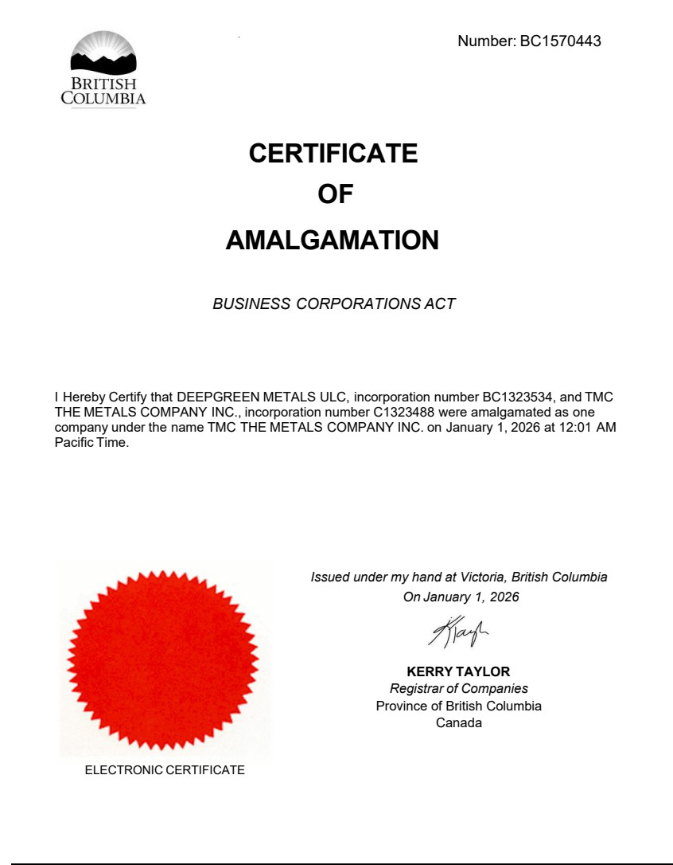

Exhibit 3.2

Certain personally identifiable information has been omitted from this exhibit pursuant to Item 601(a)(6) of Regulation S-K. [***] indicates that information has been redacted.
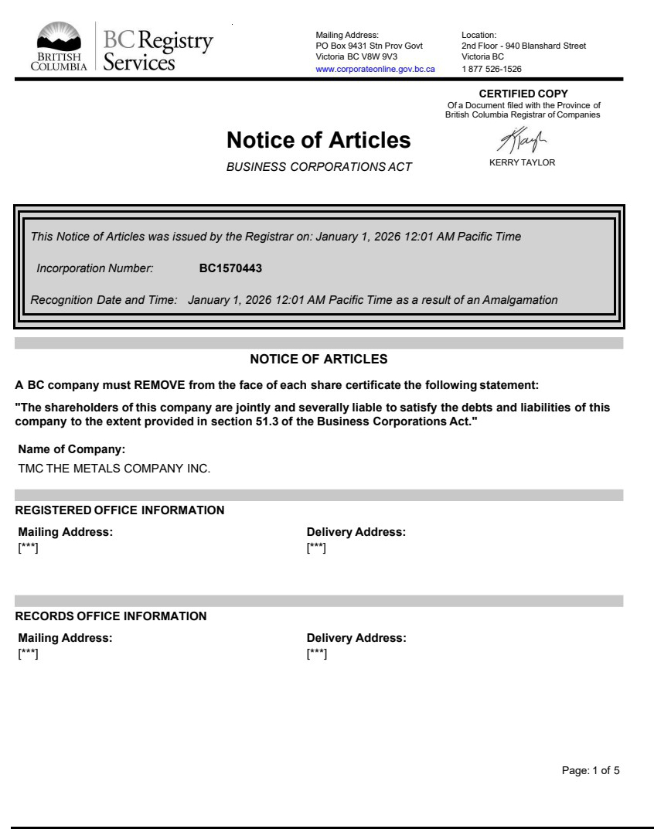

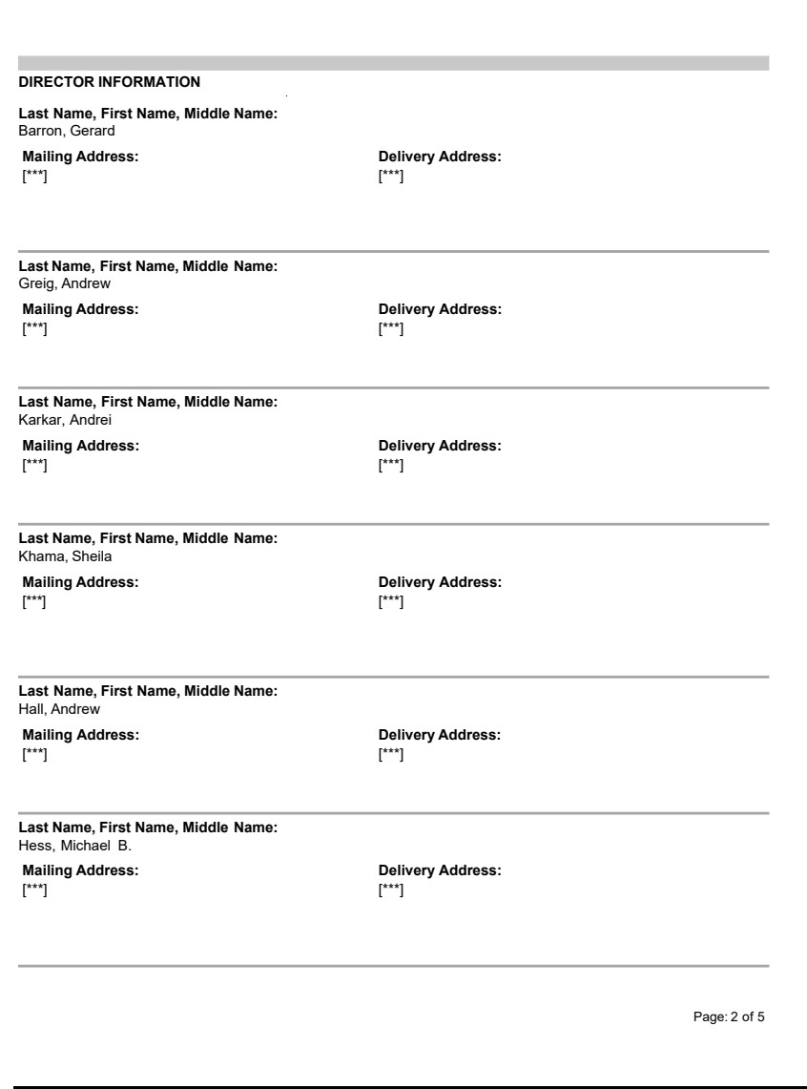

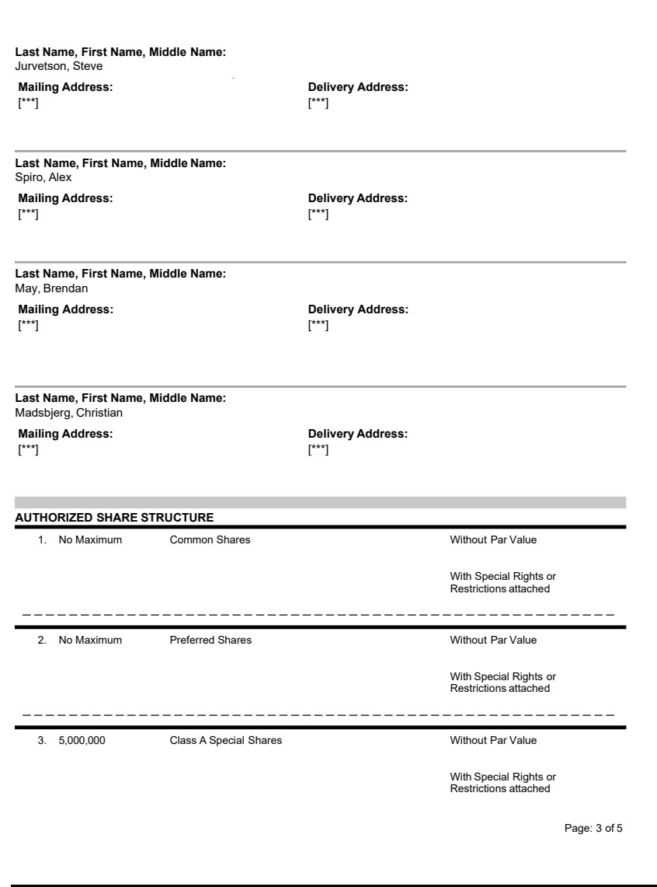

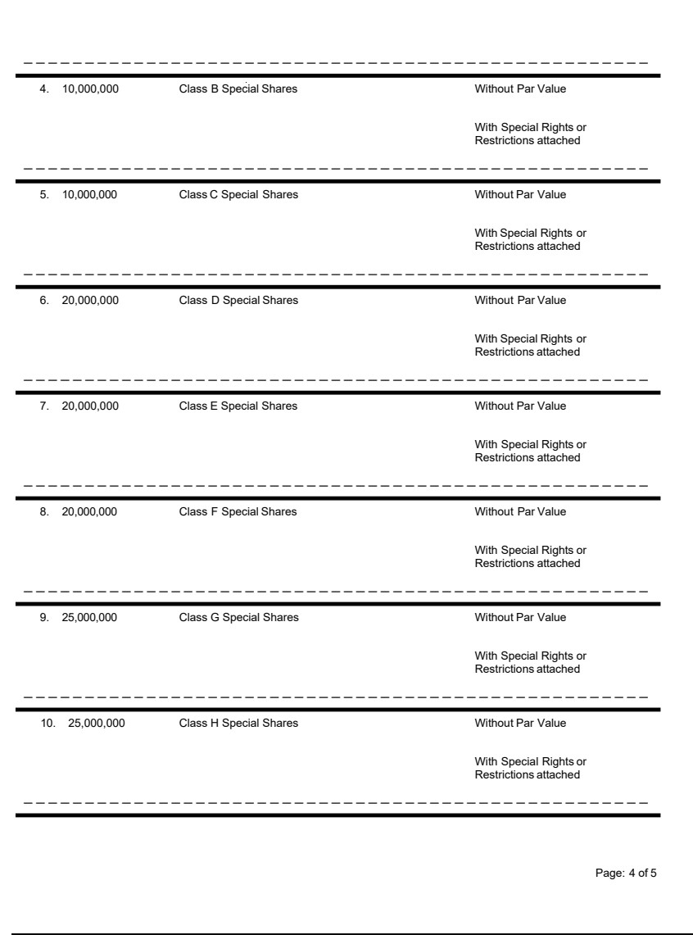

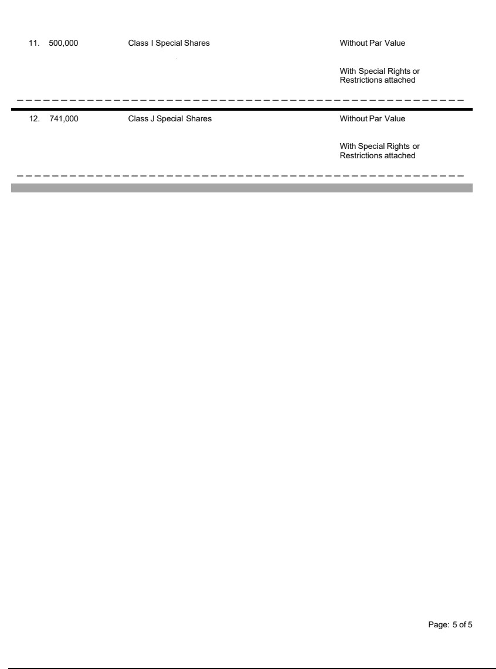

Exhibit 3.3

Incorporation Number BC1570443

Translation of Name (if any) ________________________________

PROVINCE OF BRITISH COLUMBIA

BUSINESS CORPORATIONS ACT

ARTICLES

OF

TMC THE METALS COMPANY INC.

Fasken Martineau DuMoulin LLP

Barristers & Solicitors

Canada

TABLE OF CONTENTS

PART 1 INTERPRETATION

1.1 | Definitions
1.2 | Business Corporations Act Definitions Apply
1.3 | Interpretation Act Applies
1.4 | Conflict in Definitions
1.5 | Conflict Between Articles and Legislation
PART 2 SHARES AND SHARE CERTIFICATES
2.1 | Authorized Share Structure
2.2 | Form of Share Certificate
2.3 | Right to Share Certificate or Acknowledgement
2.4 | Sending of Share Certificate
2.5 | Replacement of Worn Out or Defaced Certificate
2.6 | Replacement of Lost, Stolen or Destroyed Certificate
2.7 | Splitting Share Certificates
2.8 | Certificate Fee
2.9 | Recognition of Trusts
PART 3 ISSUE OF SHARES
3.1 | Directors Authorized to Issue Shares
3.2 | Commissions and Discounts
3.3 | Brokerage
3.4 | Conditions of Issue
3.5 | Warrants, Options and Rights
3.6 | Fractional Shares
PART 4 SHARE REGISTERS
4.1 | Central Securities Register
4.2 | Branch Registers
4.3 | Appointment of Agents
4.4 | Closing Register
PART 5 SHARE TRANSFERS
5.1 | Recording or Registering Transfer
5.2 | Form of Instrument of Transfer
5.3 | Transferor Remains Shareholder
5.4 | Signing of Instrument of Transfer
5.5 | Enquiry as to Title Not Required
5.6 | Transfer Fee
PART 6 TRANSMISSION OF SHARES
6.1 | Legal Personal Representative Recognized on Death
6.2 | Rights of Legal Personal Representative
PART 7 PURCHASE OF SHARES
7.1 | Company Authorized to Purchase Shares
7.2 | Purchase When Insolvent
7.3 | Sale and Voting of Purchased Shares
PART 8 BORROWING POWERS
8.1 | Powers of Directors
8.2 | Terms of Debt Instruments
8.3 | Delegation by Directors

Page

1

1

1

1

1

1

1

1

1

2

2

2

2

2

2

2

2

2

2

3

3

3

3

3

3

3

3

3

3

3

3

4

4

4

4

4

4

4

4

4

4

4

5

5

5

5

FASKEN MARTINEAU DUMOULIN LLP

 | TABLE OF CONTENTS
 | (continued)
PART 9 ALTERATIONS |  | 5
9.1 | Alteration of Authorized Share Structure | 5
9.2 | Special Rights and Restrictions | 6
9.3 | Change of Name | 6
9.4 | Company Alterations | 6
PART 10 MEETINGS OF SHAREHOLDERS |  | 6
10.1 | Annual General Meetings | 6
10.2 | Resolution Instead of Annual General Meeting | 6
10.3 | Calling of Shareholder Meetings | 6
10.4 | Location of Shareholder Meetings | 6
10.5 | Notice for Meetings of Shareholders | 6
10.6 | Record Date for Notice | 6
10.7 | Record Date for Voting | 6
10.8 | Failure to Give Notice and Waiver of Notice | 7
10.9 | Notice of Special Business at Meetings of Shareholders | 7
10.10 | Class Meetings and Series Meetings of Shareholders | 7
10.11 | Notice of Dissent Rights | 7
PART 11 PROCEEDINGS AT MEETINGS OF SHAREHOLDERS |  | 7
11.1 | Special Business | 7
11.2 | Special Majority | 8
11.3 | Quorum | 8
11.4 | One Shareholder May Constitute Quorum | 8
11.5 | Meetings by Telephone or Other Communications Medium | 8
11.6 | Other Persons May Attend | 8
11.7 | Requirement of Quorum | 8
11.8 | Lack of Quorum | 8
11.9 | Lack of Quorum at Succeeding Meeting | 8
11.10 | Chair | 8
11.11 | Selection of Alternate Chair | 8
11.12 | Adjournments | 9
11.13 | Notice of Adjourned Meeting | 9
11.14 | Decisions by Show of Hands or Poll | 9
11.15 | Declaration of Result | 9
11.16 | Motion Need Not Be Seconded | 9
11.17 | Casting Vote | 9
11.18 | Manner of Taking a Poll | 9
11.19 | Demand for a Poll on Adjournment | 9
11.20 | Chair Must Resolve Dispute | 9
11.21 | Casting of Votes | 9
11.22 | Demand for Poll | 9
11.23 | Demand for a Poll Not to Prevent Continuation of Meeting | 9
11.24 | Retention of Ballots and Proxies | 9
11.25 | Electronic Voting | 10
PART 12 VOTES OF SHAREHOLDERS |  | 10
12.1 | Number of Votes by Shareholder or by Shares | 10
12.2 | Votes of Persons in Representative Capacity | 10
12.3 | Votes by Joint Shareholders | 10
12.4 | Legal Personal Representatives as Joint Shareholders | 10
12.5 | Representative of a Corporate Shareholder | 10
12.6 | Proxy Provisions Do Not Apply to All Companies | 11
 | -ii- | FASKEN MARTINEAU DUMOULIN LLP

 | TABLE OF CONTENTS
 | (continued)
12.7 | Appointment of Proxy Holder | 11
12.8 | Alternate Proxy Holders | 11
12.9 | When Proxy Holder Need Not Be Shareholder | 11
12.10 | Deposit of Proxy | 11
12.11 | Validity of Proxy Vote | 11
12.12 | Form of Proxy | 11
12.13 | Revocation of Proxy | 12
12.14 | Revocation of Proxy Must Be Signed | 12
12.15 | Production of Evidence of Authority to Vote | 12
PART 13 DIRECTORS |  | 12
13.1 | Number of Directors | 12
13.2 | Change in Number of Directors | 12
13.3 | Directors’ Acts Valid Despite Vacancy | 12
13.4 | Qualifications of Directors | 12
13.5 | Remuneration of Directors | 13
13.6 | Reimbursement of Expenses of Directors | 13
13.7 | Special Remuneration for Directors | 13
13.8 | Gratuity, Pension or Allowance on Retirement of Director | 13
PART 14 ELECTION AND REMOVAL OF DIRECTORS |  | 13
14.1 | Election at Annual General Meeting | 13
14.2 | Consent to be a Director | 13
14.3 | Failure to Elect or Appoint Directors | 13
14.4 | Places of Retiring Directors Not Filled | 13
14.5 | Directors May Fill Casual Vacancies | 14
14.6 | Remaining Directors Power to Act | 14
14.7 | Shareholders May Fill Vacancies | 14
14.8 | Additional Directors | 14
14.9 | Ceasing to be a Director | 14
14.10 | Removal of Director by Shareholders | 14
14.11 | Removal of Director by Directors | 14
PART 15 ADVANCE NOTICE REQUIREMENTS |  | 14
15.1 | Definitions | 14
15.2 | Nomination of Directors | 15
15.3 | Timely Notice | 15
15.4 | Manner of Timely Notice | 15
15.5 | Proper Form of Timely Notice | 15
15.6 | Notice to be Updated | 16
15.7 | Eligibility for Nomination as a Director | 16
15.8 | Delivery of Notice | 16
15.9 | Board’s Discretion | 16
PART 16 FORUM FOR ADJUDICATION OF CERTAIN DISPUTES |  | 16
16.1 | Forum Selection | 16
PART 17 POWERS AND DUTIES OF DIRECTORS |  | 17
17.1 | Powers of Management | 17
17.2 | Appointment of Attorney of Company | 17
PART 18 DISCLOSURE OF INTEREST OF DIRECTORS |  | 17
18.1 | Obligation to Account for Profits | 17
18.2 | Restrictions on Voting by Reason of Interest | 17
 | -iii- | FASKEN MARTINEAU DUMOULIN LLP

 | TABLE OF CONTENTS
 | (continued)
18.3 | Interested Director Counted in Quorum | 17
18.4 | Disclosure of Conflict of Interest or Property | 17
18.5 | Director Holding Other Office in the Company | 17
18.6 | No Disqualification | 17
18.7 | Professional Services by Director or Officer | 17
18.8 | Director or Officer in Other Corporations | 18
PART 19 PROCEEDINGS OF DIRECTORS |  | 18
19.1 | Meetings of Directors | 18
19.2 | Voting at Meetings | 18
19.3 | Chair of Meetings | 18
19.4 | Meetings by Telephone or Other Communications Medium | 18
19.5 | Calling of Meetings | 18
19.6 | Notice of Meetings | 18
19.7 | When Notice Not Required | 18
19.8 | Meeting Valid Despite Failure to Give Notice | 18
19.9 | Waiver of Notice of Meetings | 18
19.10 | Quorum | 19
19.11 | Validity of Acts Where Appointment Defective | 19
19.12 | Consent Resolutions in Writing | 19
PART 20 EXECUTIVE AND OTHER COMMITTEES |  | 19
20.1 | Appointment and Powers of Executive Committee | 19
20.2 | Appointment and Powers of Other Committees | 19
20.3 | Obligations of Committee | 19
20.4 | Powers of Board | 20
20.5 | Committee Meetings | 20
PART 21 OFFICERS |  | 20
21.1 | Appointment of Officers | 20
21.2 | Functions, Duties and Powers of Officers | 20
21.3 | Qualifications | 20
21.4 | Remuneration | 20
PART 22 INDEMNIFICATION |  | 20
22.1 | Definitions | 20
22.2 | Mandatory Indemnification of Directors and Former Directors | 21
22.3 | Indemnification of Other Persons | 21
22.4 | Non-Compliance with Business Corporations Act | 21
22.5 | Company May Purchase Insurance | 21
PART 23 DIVIDENDS |  | 21
23.1 | Payment of Dividends Subject to Special Rights | 21
23.2 | Declaration of Dividends | 21
23.3 | No Notice Required | 21
23.4 | Record Date | 21
23.5 | Manner of Paying Dividend | 21
23.6 | Settlement of Difficulties | 21
23.7 | When Dividend Payable | 22
23.8 | Dividends to be Paid in Accordance with Number of Shares | 22
23.9 | Receipt by Joint Shareholders | 22
23.10 | Dividend Bears No Interest | 22
23.11 | Fractional Dividends | 22
23.12 | Payment of Dividends | 22
23.13 | Capitalization of Surplus | 22
23.14 | Unclaimed Dividends | 22
 | -iv- | FASKEN MARTINEAU DUMOULIN LLP

 | TABLE OF CONTENTS
 | (continued)
PART 24 DOCUMENTS, RECORDS AND REPORTS |  | 22
24.1 | Recording of Financial Affairs | 22
24.2 | Inspection of Accounting Records | 22
24.3 | Remuneration of Auditors | 22
PART 25 NOTICES |  | 23
25.1 | Method of Giving Notice | 23
25.2 | Deemed Receipt | 23
25.3 | Certificate of Sending | 23
25.4 | Notice to Joint Shareholders | 23
25.5 | Notice to Trustees | 23
PART 26 SEAL |  | 24
26.1 | Who May Attest Seal | 24
26.2 | Sealing Copies | 24
26.3 | Mechanical Reproduction of Seal | 24
PART 27 PROHIBITIONS |  | 24
27.1 | Definitions | 24
27.2 | Application | 24
27.3 | Consent Required for Transfer of Shares or Designated Securities | 25
PART 28 DEFINITIONS |  | 25
28.1 | Definitions | 25
PART 29 COMMON SHARES |  | 27
29.1 | Voting | 27
29.2 | Dividends | 27
29.3 | Liquidation Distribution | 27
PART 30 SPECIAL SHARES |  | 27
30.1 | Non-Voting | 27
30.2 | Dividends | 27
30.3 | Liquidation Distribution | 27
30.4 | Redemption | 27
30.5 | Limits on Transferability | 27
30.6 | Conversion Provisions | 28
PART 31 AUTOMATIC CONVERSIONS OF SPECIAL SHARES |  | 29
31.1 | Class A Special Shares | 29
31.2 | Class B Special Shares | 29
31.3 | Class C Special Shares | 29
31.4 | Class D Special Shares | 29
31.5 | Class E Special Shares | 29
31.6 | Class F Special Shares | 30
31.7 | Class G Special Shares | 30
31.8 | Class H Special Shares | 30
31.9 | Class I Special Shares | 30
31.10 | Class J Special Shares | 30
31.11 | Automatic Conversion | 30
31.12 | Effect of Automatic Conversion | 31
 | -v- | FASKEN MARTINEAU DUMOULIN LLP

TABLE OF CONTENTS

(continued)

PART 32 PREFERRED SHARES |  | 31
32.1 | Issuable in Series | 31
 | -vi- | FASKEN MARTINEAU DUMOULIN LLP

PROVINCE OF BRITISH COLUMBIA

BUSINESS CORPORATIONS ACT

ARTICLES

OF

TMC THE METALS COMPANY INC.

(the “Company”)

Incorporation Number BC1570443

Translation of Name (if any) ___________________________

PART 1

INTERPRETATION

1.1 Definitions. Without limiting Article 1.2, in these Articles, unless the context requires otherwise:

“adjourned meeting” means the meeting to which a meeting is adjourned under Article 11.8 or 11.12;

“board”, “board of directors” and “directors” mean the directors or sole director of the Company for the time being and include a committee or other delegate, direct or indirect, of the directors or director;

“Business Corporations Act” means the Business Corporations Act, S.B.C. 2002, c.57 as amended, restated or replaced from time to time, and includes its regulations;

“Interpretation Act” means the Interpretation Act, R.S.B.C. 1996, c. 238;

“legal personal representative” means the personal or other legal representative of the shareholder; and “seal” means the seal of the Company, if any.

1.2 Business Corporations Act Definitions Apply. The definitions in the Business Corporations Act apply to these Articles.

1.3 Interpretation Act Applies. The Interpretation Act applies to the interpretation of these articles as if these Articles were an enactment.

1.4 Conflict in Definitions. If there is a conflict between a definition in the Business Corporations Act and a definition or rule in the Interpretation Act relating to a term used in these Articles, the definition in the Business Corporations Act will prevail in relation to the use of the term in these Articles.

1.5 Conflict Between Articles and Legislation. If there is a conflict between these Articles and the Business Corporations Act, the Business Corporations Act will prevail.

PART 2

SHARES AND SHARE CERTIFICATES

2.1 Authorized Share Structure. The authorized share structure of the Company consists of shares of the class or classes and series, if any, described in the Notice of Articles of the Company.

2.2 Form of Share Certificate. Each share certificate issued by the Company must comply with, and be signed as required by, the Business Corporations Act.

- 1 - FASKEN MARTINEAU DUMOULIN LLP

2.3 Right to Share Certificate or Acknowledgement. Each shareholder is entitled, without charge, to:

- one certificate representing the share or shares of each class or series of shares registered in the shareholder’s name; or

- a non-transferable written acknowledgment of the shareholder’s right to obtain such a share certificate,

provided that in respect of a share held jointly by several persons, the Company is not bound to issue more than one share certificate or acknowledgement and delivery of a share certificate or acknowledgment for a share to one of several joint shareholders or to one of the shareholder’s duly authorized agents will be sufficient delivery to all. The Company may refuse to register more than three persons as joint holders of a share.

2.4 Sending of Share Certificate. Any share certificate or non-transferable written acknowledgment of the shareholder’s right to obtain such a share certificate to which a shareholder is entitled may be sent to the shareholder by mail at the shareholder’s registered address, and neither the Company nor any agent is liable for any loss to the shareholder because the share certificate or acknowledgment sent is lost in the mail or stolen.

2.5 Replacement of Worn Out or Defaced Certificate. If the board of directors, or any officer or agent designated by the directors, is satisfied that a share certificate is worn out or defaced, they must, on production to them of the certificate and on such other terms, if any, as they think fit:

- order the certificate to be cancelled; and

- issue a replacement share certificate.

2.6 Replacement of Lost, Stolen or Destroyed Certificate. If a share certificate is lost, stolen or destroyed, a replacement share certificate must be issued to the person entitled to that certificate if the board of directors, or any officer or agent designated by the directors, receives:

- proof satisfactory to them that the certificate is lost, stolen or destroyed; and

- any indemnity the board of directors, or any officer or agent designated by the directors, considers adequate.

2.7 Splitting Share Certificates. If a shareholder surrenders a share certificate to the Company with a written request that the Company issue in the shareholder’s name two or more certificates, each representing a specified number of shares and in the aggregate representing the same number of shares as the certificate so surrendered, the Company must cancel the surrendered certificate and issue replacement share certificates in accordance with that request. The Company may refuse to issue a certificate with respect to a fraction of a share.

2.8 Certificate Fee. There must be paid to the Company, in relation to the issue of any share certificate under Articles 2.5, 2.6 or 2.7, the amount, if any and which must not exceed the amount prescribed under the Business Corporations Act, determined by the directors.

2.9 Recognition of Trusts. Except as required by law or statute or these Articles, no person will be recognized by the Company as holding any share upon any trust, and the Company is not bound by or compelled in any way to recognize (even when having notice thereof) any equitable, contingent, future or partial interest in any share or fraction of a share or (except as by law or statute or these Articles provided or as ordered by a court of competent jurisdiction) any other rights in respect of any share except an absolute right to the entirety thereof in the shareholder.

PART 3

ISSUE OF SHARES

3.1 Directors Authorized to Issue Shares. Subject to the Business Corporations Act and the rights of the holders of issued shares of the Company, the directors may issue, allot, sell or otherwise dispose of the unissued shares, and previously issued shares that are subject to reissuance or held by the Company, whether with par value or without par value, at the times, to the persons, including directors, in the manner, on the terms and conditions and for the issue prices (including any premium at which shares may be issued) that the directors, in their absolute discretion, may determine. The issue price for a share with par value must be equal to or greater than the par value of the share.

3.2 Commissions and Discounts. The directors may, at any time, authorize the Company to pay a reasonable commission or allow a reasonable discount to any person in consideration of that person purchasing or agreeing to purchase shares of the Company from the Company or any other person or procuring or agreeing to procure purchasers for shares of the Company.

- 2 - FASKEN MARTINEAU DUMOULIN LLP

3.3 Brokerage. The directors may authorize the Company to pay such brokerage fee or other consideration as may be lawful for or in connection with the sale or placement of its securities.

3.4 Conditions of Issue. Except as provided for by the Business Corporations Act, no share may be issued until it is fully paid. A share is fully paid when:

- consideration is provided to the Company for the issue of the share by one or more of the following:

  - past services performed for the Company;

  - property; or

  - money; and

- the value of the consideration received by the Company equals or exceeds the issue price set for the share under Article 3.1.

3.5 Warrants, Options and Rights. Subject to the Business Corporations Act, the Company may issue warrants, options and rights upon such terms and conditions as the directors determine, which warrants, options and rights may be issued alone or in conjunction with debentures, debenture stock, bonds, shares or any other securities issued or created by the Company from time to time.

3.6 Fractional Shares. A person holding a fractional share does not have, in relation to the fractional share, the rights of a shareholder in proportion to the fraction of the share held.

PART 4

SHARE REGISTERS

4.1 Central Securities Register. As required by and subject to the Business Corporations Act, the Company must maintain in British Columbia a central securities register.

4.2 Branch Registers. In addition to the central securities register, the Company may maintain branch securities registers.

4.3 Appointment of Agents. The directors may, subject to the Business Corporations Act, appoint an agent to maintain the central securities register and any branch securities registers. The directors may also appoint one or more agents, including the agent which keeps the central securities register, as transfer agent for its shares or any class or series of its shares, as the case may be, and the same or another agent as registrar for its shares or such class or series of its shares, as the case may be. The directors may terminate such appointment of any agent at any time and may appoint another agent in its place.

4.4 Closing Register. The Company must not at any time close its central securities register.

PART 5

SHARE TRANSFERS

5.1 Recording or Registering Transfer. Except to the extent that the Business Corporations Act otherwise provides, a transfer of a share of the Company must not be recorded or registered unless:

- a duly signed instrument of transfer in respect of the share has been received by the Company;

- if a share certificate has been issued by the Company in respect of the share to be transferred, that share certificate has been surrendered to the Company; and

- if a non-transferable written acknowledgment of the shareholder’s right to obtain a share certificate has been issued by the Company in respect of the share to be transferred, that acknowledgment has been surrendered to the Company.

5.2 Form of Instrument of Transfer. The instrument of transfer in respect of any share of the Company must be either in the form, if any, on the back of the Company’s share certificates or in any other form that may be approved by the directors from time to time.

- 3 - FASKEN MARTINEAU DUMOULIN LLP

5.3 Transferor Remains Shareholder. Except to the extent that the Business Corporations Act otherwise provides, the transferor of shares is deemed to remain the holder of the shares until the name of the transferee is entered in a securities register of the Company in respect of the transfer.

5.4 Signing of Instrument of Transfer. If a shareholder, or his or her duly authorized attorney, signs an instrument of transfer in respect of shares registered in the name of the shareholder, the signed instrument of transfer constitutes a complete and sufficient authority to the Company and its directors, officers and agents to register the number of shares specified in the instrument of transfer, or, if no number is specified, all the shares represented by share certificates deposited with the instrument of transfer:

- in the name of the person named as transferee in that instrument of transfer; or

- if no person is named as transferee in that instrument of transfer, in the name of the person on whose behalf the share certificate is deposited for the purpose of having the transfer registered.

5.5 Enquiry as to Title Not Required. Neither the Company nor any director, officer or agent of the Company is bound to inquire into the title of the person named in the instrument of transfer as transferee or, if no person is named as transferee in the instrument of transfer, of the person on whose behalf the instrument is deposited for the purpose of having the transfer registered or is liable for any claim related to registering the transfer by the shareholder or by any intermediate owner or holder of the shares, of any interest in the shares, of any share certificate representing such shares or of any written acknowledgment of a right to obtain a share certificate for such shares.

5.6 Transfer Fee. Subject to the applicable rules of any stock exchange on which the shares of the Company may be listed, there must be paid to the Company, in relation to the registration of any transfer, the amount determined by the directors.

PART 6

TRANSMISSION OF SHARES

6.1 Legal Personal Representative Recognized on Death. In the case of the death of a shareholder, the legal personal representative, or if the shareholder was a joint holder, the surviving joint holder, will be the only person recognized by the Company as having any title to the shareholder’s interest in the shares. Before recognizing a person as a legal personal representative, the directors may require proof of appointment by a court of competent jurisdiction, a grant of letters probate, letters of administration or such other evidence or documents as the directors consider appropriate.

6.2 Rights of Legal Personal Representative. The legal personal representative has the same rights, privileges and obligations that attach to the shares held by the shareholder, including the right to transfer the shares in accordance with these Articles, provided the documents required by the Business Corporations Act and the directors have been deposited with the Company.

PART 7

PURCHASE OF SHARES

7.1 Company Authorized to Purchase Shares. Subject to the special rights and restrictions attached to any class or series of shares and the Business Corporations Act, the Company may, if authorized by the directors, purchase or otherwise acquire any of its shares at the price and on the terms specified in such resolution.

7.2 Purchase When Insolvent. The Company must not make a payment or provide any other consideration to purchase or otherwise acquire any of its shares if there are reasonable grounds for believing that:

- the Company is insolvent; or

- making the payment or providing the consideration would render the Company insolvent.

7.3 Sale and Voting of Purchased Shares. If the Company retains a share redeemed, purchased or otherwise acquired by it, the Company may sell, gift or otherwise dispose of the share, but, while such share is held by the Company, it:

- is not entitled to vote the share at a meeting of its shareholders;

- must not pay a dividend in respect of the share; and

- must not make any other distribution in respect of the share.

- 4 - FASKEN MARTINEAU DUMOULIN LLP

PART 8

BORROWING POWERS

8.1 Powers of Directors. The Company, if authorized by the directors, may from time to time:

- borrow money in the manner and amount, on the security, from the sources and on the terms and conditions that the directors consider appropriate;

- issue bonds, debentures and other debt obligations either outright or as security for any liability or obligation of the Company or any other person;

- guarantee the repayment of money by any other person or the performance of any obligation of any other person; and

- mortgage or charge, whether by way of specific or floating charge, or give other security on the whole or any part of the present and future undertaking of the Company.

8.2 Terms of Debt Instruments. Any bonds, debentures or other debt obligations of the Company may be issued at a discount, premium or otherwise, and with any special privileges on the redemption, surrender, drawing, allotment of or conversion into or exchange for shares or other securities, attending and voting at general meetings of the Company, appointment of directors or otherwise, and may by their terms be assignable free from any equities between the Company and the person to whom they were issued or any subsequent holder, all as the directors may determine.

8.3 Delegation by Directors. For greater certainty, the powers of the directors under this Part 8 may be exercised by a committee or other delegate, direct or indirect, of the board authorized to exercise such powers.

PART 9

ALTERATIONS

9.1 Alteration of Authorized Share Structure. Subject to Article 9.2 and the Business Corporations Act, the Company may:

- by ordinary resolution:

  - create one or more classes or series of shares or, if none of the shares of a class or series of shares is allotted or issued, eliminate that class or series of shares;

  - increase, reduce or eliminate the maximum number of shares that the Company is authorized to issue out of any class or series of shares or establish a maximum number of shares that the Company is authorized to issue out of any class or series of shares for which no maximum is established;

  - subdivide or consolidate all or any of its unissued, or fully paid issued, shares;

  - if the Company is authorized to issue shares of a class of shares with par value:

    - decrease the par value of those shares; or

    - if none of the shares of that class of shares is allotted or issued, increase the par value of those shares;

  - change all or any of its unissued, or fully paid issued, shares with par value into shares without par value or any of its unissued shares without par value into shares with par value;

  - alter the identifying name of any of its shares; or

  - otherwise alter its shares or authorized share structure when required or permitted to do so by the Business Corporations Act.; or

- by directors’ resolution, subdivide or consolidate all or any of its unissued, or fully paid issued, shares.

- 5 - FASKEN MARTINEAU DUMOULIN LLP

9.2 Special Rights and Restrictions. Subject to the Business Corporations Act, the Company may by ordinary resolution:

- create special rights or restrictions for, and attach those special rights or restrictions to, the shares of any class or series of shares, whether or not any or all of those shares have been issued; or

- vary or delete any special rights or restrictions attached to the shares of any class or series of shares, whether or not any or all of those shares have been issued.

9.3 Change of Name. The Company may by directors’ resolution or ordinary resolution authorize an alteration of its Notice of Articles in order to change its name.

9.4 Company Alterations. If the Business Corporations Act does not specify the type of resolution and these Articles do not specify a type of resolution, the Company may by ordinary resolution authorize any act of the Company, including without limitation, an alteration of these Articles or its Notice of Articles.

PART 10

MEETINGS OF SHAREHOLDERS

10.1 Annual General Meetings. Unless an annual general meeting is deferred or waived in accordance with the Business Corporations Act, the Company must hold an annual general meeting, for the first time, not more than 18 months after the date on which it was recognized, and after its first annual reference date, at least once in each calendar year and not more than 15 months after the annual reference date for the preceding calendar year at such date, time and location as may be determined by the directors.

10.2 Resolution Instead of Annual General Meeting. If all of the shareholders who are entitled to vote at an annual general meeting consent by a unanimous resolution under the Business Corporations Act to all of the business that is required to be transacted at that annual general meeting, the annual general meeting is deemed to have been held on the date of the unanimous resolution. The shareholders must, in any unanimous resolution passed under this Article 10.2, select as the Company’s annual reference date a date that would be appropriate for the holding of the applicable annual general meeting.

10.3 Calling of Shareholder Meetings. The directors may, whenever they think fit, call a meeting of shareholders.

10.4 Location of Shareholder Meetings. The directors may by directors’ resolution, approve a location outside of British Columbia for the holding of a meeting of shareholders.

10.5 Notice for Meetings of Shareholders. The Company must send notice of the date, time and location of any meeting of shareholders, in the manner provided in these Articles, or in such other manner, if any, as may be prescribed by ordinary resolution (whether previous notice of the resolution has been given or not), to each shareholder entitled to attend the meeting, to each director and to the auditor of the Company, unless these Articles otherwise provide, at least the following number of days before the meeting:

- if and for so long as the Company is a public company, 21 days; and

- otherwise, 10 days.

10.6 Record Date for Notice. The directors may set a date as the record date for the purpose of determining shareholders entitled to notice of any meeting of shareholders. The record date must not precede the date on which the meeting is to be held by more than two months or, in the case of a general meeting requisitioned by shareholders under the Business Corporations Act, by more than four months. The record date must not precede the date on which the meeting is held by fewer than:

- if and for so long as the Company is a public company, 21 days; and

- otherwise, 10 days.

If no record date is set, the record date is 5 p.m. on the day immediately preceding the first date on which the notice is sent or, if no notice is sent, the beginning of the meeting.

10.7 Record Date for Voting. The directors may set a date as the record date for the purpose of determining shareholders entitled to vote at any meeting of shareholders. The record date must not precede the date on which the meeting is to be held by more than two months or, in the case of a general meeting requisitioned by shareholders under the Business Corporations Act, by more than four months. If no record date is set, the record date is 5 p.m. on the day immediately preceding the first date on which the notice is sent or, if no notice is sent, the beginning of the meeting.

- 6 - FASKEN MARTINEAU DUMOULIN LLP

10.8 Failure to Give Notice and Waiver of Notice. The accidental omission to send notice of any meeting to, or the non-receipt of any notice by, any of the persons entitled to receive notice does not invalidate any proceedings at that meeting. Any person entitled to receive notice of a meeting of shareholders may, in writing or otherwise, waive or reduce the period of notice of such meeting.

10.9 Notice of Special Business at Meetings of Shareholders. If a meeting of shareholders is to consider special business within the meaning of Article 11.1, the notice of meeting must:

- state the general nature of the special business; and

- if the special business includes considering, approving, ratifying, adopting or authorizing any document or the signing of or giving of effect to any document, have attached to it a copy of the document or state that a copy of the document will be available for inspection by the shareholders:

  - at the Company’s records office, or at such other reasonably accessible location in British Columbia as is specified in the notice; and

  - during statutory business hours on any one or more specified days before the day set for the holding of the meeting.

10.10 Class Meetings and Series Meetings of Shareholders. Unless otherwise specified in these Articles, the provisions of these Articles relating to a meeting of shareholders will apply with the necessary changes and so far as they are applicable, to a class meeting or series meeting of shareholders holding a particular class or series of shares.

10.11 Notice of Dissent Rights. The Company must send to each of its shareholders, whether or not their shares carry the right to vote, a notice of any meeting of shareholders at which a resolution entitling shareholders to dissent is to be considered specifying the date of the meeting and containing a statement advising of the right to send a notice of dissent together with a copy of the proposed resolution at least the following number of days before the meeting:

- if and for so long as the Company is a public company, 21 days;

- otherwise, 10 days.

PART 11

PROCEEDINGS AT MEETINGS OF SHAREHOLDERS

11.1 Special Business. At a meeting of shareholders, the following business is special business:

- at a meeting of shareholders that is not an annual general meeting, all business is special business except business relating to the conduct of or voting at the meeting;

- at an annual general meeting, all business is special business except for the following:

  - business relating to the conduct of, or voting at, the meeting;

  - consideration of any financial statements of the Company presented to the meeting;

  - consideration of any reports of the directors or auditor;

  - the setting or changing of the number of directors;

  - the election or appointment of directors;

  - the appointment of an auditor;

  - business arising out of a report of the directors not requiring the passing of a special resolution or an exceptional resolution; and

- 7 - FASKEN MARTINEAU DUMOULIN LLP

- any other business which, under these Articles or the Business Corporations Act, may be transacted at a meeting of shareholders without prior notice of the business being given to the shareholders.

11.2 Special Majority. The majority of votes required for the Company to pass a special resolution at a meeting of shareholders is two-thirds of the votes cast on the resolution.

11.3 Quorum. Subject to the special rights and restrictions attached to the shares of any class or series of shares, the quorum for the transaction of business at a meeting of shareholders is two persons who are, or who represent by proxy, shareholders who, in the aggregate, hold at least 5% of the issued shares entitled to be voted at the meeting.

11.4 One Shareholder May Constitute Quorum. If there is only one shareholder entitled to vote at a meeting of shareholders:

- the quorum is one person who is, or who represents by proxy, that shareholder; and

- that shareholder, present in person or by proxy, may constitute the meeting.

11.5 Meetings by Telephone or Other Communications Medium. A shareholder or proxy holder who is entitled to participate in, including vote at, a meeting of shareholders may participate in person or by telephone or other communications medium if all shareholders and proxy holders participating in the meeting, whether in person or by telephone or other communications medium, are able to communicate with each other. A shareholder who participates in a meeting in a manner contemplated by this Article 11.5 is deemed for all purposes of the Business Corporations Act and these Articles to be present at the meeting and to have agreed to participate in that manner. Nothing in this Article 11.5 obligates the Company to take any action or provide any facility to permit or facilitate the use of any communications mediums at a meeting of shareholders.

11.6 Other Persons May Attend. The directors, the president (if any), the secretary (if any), the assistant secretary (if any), any lawyer for the Company, the auditor of the Company and any other persons invited by the directors are entitled to attend any meeting of shareholders, but if any of those persons does attend a meeting of shareholders, that person is not to be counted in the quorum, and is not entitled to vote at the meeting, unless that person is a shareholder or proxy holder entitled to vote at the meeting.

11.7 Requirement of Quorum. No business, other than the election of a chair of the meeting and the adjournment of the meeting, may be transacted at any meeting of shareholders unless a quorum of shareholders entitled to vote is present at the commencement of the meeting.

11.8 Lack of Quorum. If, within one-half hour from the time set for the holding of a meeting of shareholders, a quorum is not present:

- in the case of a general meeting convened by requisition of shareholders, the meeting is dissolved; and

- in the case of any other meeting of shareholders, the meeting stands adjourned to the same day in the next week at the same time and place, or at such other date, time or location as the chair specifies on the adjournment.

11.9 Lack of Quorum at Succeeding Meeting. If, at the meeting to which the first meeting referred to in Article 11.8(b) was adjourned, a quorum is not present within one-half hour from the time set for the holding of the meeting the person or persons present and being, or representing by proxy, one or more shareholders entitled to attend and vote at the meeting constitute a quorum.

11.10 Chair. The following individual is entitled to preside as chair at a meeting of shareholders:

- the chair of the board, if any; and

- if the chair of the board is absent or unwilling to act as chair of the meeting, the president, if any.

11.11 Selection of Alternate Chair. If, at any meeting of shareholders, there is no chair of the board or president present within 15 minutes after the time set for holding the meeting, or if the chair of the board and the president are unwilling to act as chair of the meeting, or if the chair of the board and the president have advised the secretary, if any, or any director present at the meeting, that they will not be present at the meeting, the directors present must choose one of their number to be chair of the meeting or if all of the directors present decline to take the chair or fail to so choose or if no director is present, the shareholders entitled to vote at the meeting who are present in person or by proxy may choose any person present at the meeting to chair the meeting.

- 8 - FASKEN MARTINEAU DUMOULIN LLP

11.12 Adjournments. The chair of a meeting of shareholders may, and if so directed by the meeting must, adjourn the meeting from time to time and from place to place, but no business may be transacted at any adjourned meeting other than the business left unfinished at the meeting from which the adjournment took place.

11.13 Notice of Adjourned Meeting. It is not necessary to give any notice of an adjourned meeting or of the business to be transacted at an adjourned meeting of shareholders except that, when a meeting is adjourned for 30 days or more, notice of the adjourned meeting must be given as in the case of the original meeting.

11.14 Decisions by Show of Hands or Poll. Subject to the Business Corporations Act, every motion put to a vote at a meeting of shareholders will be decided on a show of hands or the functional equivalent of a show of hands by means of telephonic, electronic or other communications facilities, unless a poll, before or on the declaration of the result of the vote by show of hands (or its functional equivalent), is directed by the chair or demanded by at least one shareholder entitled to vote who is present in person or by proxy.

11.15 Declaration of Result. The chair of a meeting of shareholders must declare to the meeting the decision on every question in accordance with the result of the show of hands (or its functional equivalent) or the poll, as the case may be, and that decision must be entered in the minutes of the meeting. A declaration of the chair that a resolution is carried by the necessary majority or is defeated is, unless a poll is directed by the chair or demanded under Article 11.14, conclusive evidence without proof of the number or proportion of the votes recorded in favour of or against the resolution.

11.16 Motion Need Not Be Seconded. No motion proposed at a meeting of shareholders need be seconded unless the chair of the meeting rules otherwise, and the chair of any meeting of shareholders is entitled to propose or second a motion.

11.17 Casting Vote. In case of an equality of votes, the chair of a meeting of shareholders does not, either on a show of hands or on a poll, have a second or casting vote in addition to the vote or votes to which the chair may be entitled as a shareholder.

11.18 Manner of Taking a Poll. Subject to Article 11.19, if a poll is duly demanded at a meeting of shareholders:

- the poll must be taken:

  - at the meeting, or within seven days after the date of the meeting, as the chair of the meeting directs; and

  - in the manner, at the time and at the place that the chair of the meeting directs;

- the result of the poll is deemed to be a resolution of and passed at the meeting at which the poll is demanded; and

- the demand for the poll may be withdrawn by the person who demanded it.

11.19 Demand for a Poll on Adjournment. A poll demanded at a meeting of shareholders on a question of adjournment must be taken immediately at the meeting.

11.20 Chair Must Resolve Dispute. In the case of any dispute as to the admission or rejection of a vote given on a poll, the chair of the meeting must determine the dispute, and his or her determination made in good faith is final and conclusive.

11.21 Casting of Votes. On a poll, a shareholder entitled to more than one vote need not cast all the votes in the same way.

11.22 Demand for Poll. No poll may be demanded in respect of the vote by which a chair of a meeting of shareholders is elected.

11.23 Demand for a Poll Not to Prevent Continuation of Meeting. The demand for a poll at a meeting of shareholders does not, unless the chair of the meeting so rules, prevent the continuation of a meeting for the transaction of any business other than the question on which a poll has been demanded.

11.24 Retention of Ballots and Proxies. The Company must, for at least three months after a meeting of shareholders, keep each ballot cast on a poll and each proxy voted at the meeting, and, during that period, make them available for inspection during statutory business hours by any shareholder or proxy holder entitled to vote at the meeting. At the end of such three month period, the Company may destroy such ballots and proxies.

- 9 - FASKEN MARTINEAU DUMOULIN LLP

11.25 Electronic Voting. Any vote at a meeting of shareholders may be held entirely or partially by means of telephonic, electronic or other communications facilities if the directors determine to make them available whether or not persons entitled to attend participate in the meeting by means of telephonic, electronic or other communications facilities.

PART 12

VOTES OF SHAREHOLDERS

12.1 Number of Votes by Shareholder or by Shares. Subject to any special rights or restrictions attached to any shares and to the restrictions imposed on joint registered holders of shares under Article 12.3:

- on a vote by show of hands (or its functional equivalent), every person present who is a shareholder or proxy holder and entitled to vote at the meeting has one vote, and

- on a poll, every shareholder entitled to vote at the meeting has one vote in respect of each share held by that shareholder and may exercise that vote either in person or by proxy.

12.2 Votes of Persons in Representative Capacity. A person who is not a shareholder may vote at a meeting of shareholders, whether on a show of hands or on a poll, and may appoint a proxy holder to act at the meeting, if, before doing so, the person satisfies the chair of the meeting, or the directors, that the person is the legal personal representative or a trustee in bankruptcy for a shareholder who is entitled to vote at the meeting.

12.3 Votes by Joint Shareholders. If there are joint shareholders registered in respect of any share:

- any one of the joint shareholders may vote at any meeting, either personally or by proxy, in respect of the share as if that joint shareholder were solely entitled to it; or

- if more than one of the joint shareholders is present at any meeting, personally or by proxy, and more than one of them votes in respect of that share, then only the vote of the joint shareholder present whose name stands first on the central securities register in respect of the share will be counted.

12.4 Legal Personal Representatives as Joint Shareholders. Two or more legal personal representatives of a shareholder in whose sole name any share is registered are, for the purposes of Article 12.3, deemed to be joint shareholders.

12.5 Representative of a Corporate Shareholder. If a corporation that is not a subsidiary of the Company is a shareholder, that corporation may appoint a person to act as its representative at any meeting of shareholders of the Company, and:

- for that purpose, the instrument appointing a representative must:

  - be received at the registered office of the Company or at any other place specified, in the notice calling the meeting, for the receipt of proxies, at least the number of business days specified in the notice for the receipt of proxies or, if no number is specified, two days before the day set for the holding of the meeting; or

  - be provided, at the meeting, to the chair of the meeting or to a person designated by the chair of the meeting; and

- if a representative is appointed under this Article 12.5:

  - the representative is entitled to exercise in respect of and at that meeting the same rights on behalf of the corporation that the representative represents as that corporation could exercise if it were a shareholder who is an individual, including, without limitation, the right to appoint a proxy holder; and

  - the representative, if present at the meeting, is to be counted for the purpose of forming a quorum and is deemed to be a shareholder present in person at the meeting.

Evidence of the appointment of any such representative may be sent to the Company by written instrument, fax or any other method of transmitting legibly recorded messages.

- 10 - FASKEN MARTINEAU DUMOULIN LLP

12.6 Proxy Provisions Do Not Apply to All Companies. If and for so long as it is a public company, Articles 12.7 to 12.15 apply only insofar as they are not inconsistent with any Canadian securities legislation applicable to the Company, any U.S. securities legislation applicable to the Company or any rules of an exchange on which securities of the Company are listed.

12.7 Appointment of Proxy Holder. Every shareholder of the Company, including a corporation that is a shareholder but not a subsidiary of the Company, entitled to vote at a meeting of shareholders of the Company may, by proxy, appoint one or more (but not more than five) proxy holders to attend and act at the meeting in the manner, to the extent and with the powers conferred by the proxy.

12.8 Alternate Proxy Holders. A shareholder may appoint one or more alternate proxy holders to act in the place of an absent proxy holder.

12.9 When Proxy Holder Need Not Be Shareholder. A person must not be appointed as a proxy holder unless the person is a shareholder, although a person who is not a shareholder may be appointed as a proxy holder if:

- the person appointing the proxy holder is a corporation or a representative of a corporation appointed under Article 12.5;

- the Company has at the time of the meeting for which the proxy holder is to be appointed only one shareholder entitled to vote at the meeting;

- the shareholders present in person or by proxy at and entitled to vote at the meeting for which the proxy holder is to be appointed, by a resolution on which the proxy holder is not entitled to vote but in respect of which the proxy holder is to be counted in the quorum, permit the proxy holder to attend and vote at the meeting; or

- the Company is a public company.

12.10 Deposit of Proxy. A proxy for a meeting of shareholders must:

- be received at the registered office of the Company or at any other place specified, in the notice calling the meeting, for the receipt of proxies, at least the number of business days specified in the notice, or if no number of days is specified, two business days before the day set for the holding of the meeting; or

- unless the notice provides otherwise, be provided, at the meeting, to the chair of the meeting or to a person designated by the chair of the meeting. A proxy may be sent to the Company by written instrument, fax or any other method of transmitting legibly recorded messages.
12.11 Validity of Proxy Vote. A vote given in accordance with the terms of a proxy is valid notwithstanding the death or incapacity of the shareholder giving the proxy and despite the revocation of the proxy or the revocation of the authority under which the proxy is given, unless notice in writing of that death, incapacity or revocation is received:

- at the registered office of the Company, at any time up to and including the last business day before the day set for the holding of the meeting at which the proxy is to be used; or

- by the chair of the meeting, before the vote is taken.

12.12 Form of Proxy. A proxy, whether for a specified meeting or otherwise, must be either in the following form or in any other form approved by the directors or the chair of the meeting:

[Name of Company]

(the “Company”)

The undersigned, being a shareholder of the Company, hereby appoints [name] or, failing that person, [name], as proxy holder for the undersigned to attend, act and vote for and on behalf of the undersigned at the meeting of shareholders to be held on [month, day, year] and at any adjournment of that meeting.

Number of shares in respect of which this proxy is given (if no number is specified, then this proxy is given in respect of all shares registered in the name of the shareholder): ______________

- 11 - FASKEN MARTINEAU DUMOULIN LLP

Signed this ____ day of _______, ________.

Signature of shareholder

Name of shareholder—printed

12.13 Revocation of Proxy. Subject to Article 12.14, every proxy may be revoked by an instrument in writing that is:

- received at the registered office of the Company at any time up to and including the last business day before the day set for the holding of the meeting at which the proxy is to be used; or

- provided, at the meeting, to the chair of the meeting.

12.14 Revocation of Proxy Must Be Signed. An instrument referred to in Article 12.13 must be signed as follows:

- if the shareholder for whom the proxy holder is appointed is an individual, the instrument must be signed by the shareholder or his or her legal personal representative or trustee in bankruptcy; or

- if the shareholder for whom the proxy holder is appointed is a corporation, the instrument must be signed by the corporation or by a representative appointed for the corporation under Article 12.5.

12.15 Production of Evidence of Authority to Vote. The chair of any meeting of shareholders may, but need not, inquire into the authority of any person to vote at the meeting and may, but need not, demand from that person production of evidence as to the existence of the authority to vote.

PART 13

DIRECTORS

13.1 Number of Directors. The number of directors, excluding additional directors appointed under Article 14.8, is set at:

- if the Company is a public company, the greater of three and the most recently set of:

  - the number of directors set by ordinary resolution (whether or not previous notice of the resolution was given); and

  - the number of directors set under Article 14.4;

- if the Company is not a public company, the most recently set of:

  - the number of directors set by ordinary resolution (whether or not previous notice of the resolution was given); and

  - the number of directors set under Article 14.4.

13.2 Change in Number of Directors. If the number of directors is set under Articles 13.1(a)(i) or 13.1(b)(i):

- the shareholders may elect or appoint the directors needed to fill any vacancies in the board of directors up to that number;

- if the shareholders do not elect or appoint the directors needed to fill any vacancies in the board of directors up to that number contemporaneously with the setting of that number, then the directors may appoint, or the shareholders may elect or appoint, directors to fill those vacancies.

13.3 Directors’ Acts Valid Despite Vacancy. An act or proceeding of the directors is not invalid merely because fewer than the number of directors set or otherwise required under these Articles is in office.

13.4 Qualifications of Directors. A director is not required to hold a share in the capital of the Company as qualification for his or her office but must be qualified as required by the Business Corporations Act to become, act or continue to act as a director.

- 12 - FASKEN MARTINEAU DUMOULIN LLP

13.5 Remuneration of Directors. The directors are entitled to the remuneration for acting as directors, if any, as the directors may from time to time determine. If the directors so decide, the remuneration of the directors, if any, will be determined by the shareholders. That remuneration may be in addition to any salary or other remuneration paid to any officer or employee of the Company as such, who is also a director.

13.6 Reimbursement of Expenses of Directors. The Company must reimburse each director for the reasonable expenses that he or she may incur in his or her capacity as director in and about the business of the Company.

13.7 Special Remuneration for Directors. If any director performs any professional or other services for the Company that in the opinion of the directors are outside the ordinary duties of a director, or if any director is otherwise specially occupied in or about the Company’s business, he or she may be paid remuneration fixed by the directors, or, at the option of that director, fixed by ordinary resolution, and such remuneration may be either in addition to, or in substitution for, any other remuneration that he or she may be entitled to receive.

13.8 Gratuity, Pension or Allowance on Retirement of Director. Unless otherwise determined by ordinary resolution, the directors may authorize the Company to pay a gratuity or pension or allowance on retirement to any director who has held any salaried office or place of profit with the Company or to his or her spouse or dependants and may make contributions to any fund and pay premiums for the purchase or provision of any such gratuity, pension or allowance.

PART 14

ELECTION AND REMOVAL OF DIRECTORS

14.1 Election at Annual General Meeting. At every annual general meeting and in every unanimous resolution contemplated by Article 10.2:

- the shareholders entitled to vote at the annual general meeting for the election of directors must elect, or in the unanimous resolution appoint, a board of directors consisting of the number of directors for the time being set under these Articles; and

- all the directors cease to hold office immediately before the election or appointment of directors under paragraph (a), but are eligible for re-election or re-appointment.

14.2 Consent to be a Director. No election, appointment or designation of an individual as a director is valid unless:

- that individual consents to be a director in the manner provided for in the Business Corporations Act; or

- that individual is elected or appointed at a meeting at which the individual is present and the individual does not refuse, at the meeting, to be a director.

14.3 Failure to Elect or Appoint Directors. If:

- the Company fails to hold an annual general meeting, and all the shareholders who are entitled to vote at an annual general meeting fail to pass the unanimous resolution contemplated by Article 10.2, on or before the date by which the annual general meeting is required to be held under the Business Corporations Act; or

- the shareholders fail, at the annual general meeting or in the unanimous resolution contemplated by Article 10.2, to elect or appoint any directors; then each director then in office continues to hold office until the earlier of:

- the date on which his or her successor is elected or appointed; and

- the date on which he or she otherwise ceases to hold office under the Business Corporations Act or these Articles.

14.4 Places of Retiring Directors Not Filled. If, at any meeting of shareholders at which there should be an election of directors, the places of any of the retiring directors are not filled by that election, those retiring directors who are not re-elected and who are asked by the newly elected directors to continue in office will, if willing to do so, continue in office to complete the number of directors for the time being set pursuant to these Articles until further new directors are elected at a meeting of shareholders convened for that purpose. If any such election or continuance of directors does not result in the election or continuance of the number of directors for the time being set pursuant to these Articles, the number of directors of the Company is deemed to be set at the number of directors actually elected or continued in office.

- 13 - FASKEN MARTINEAU DUMOULIN LLP

14.5 Directors May Fill Casual Vacancies. Any casual vacancy occurring in the board of directors may be filled by the directors.

14.6 Remaining Directors Power to Act. The directors may act notwithstanding any vacancy in the board of directors, but if the Company has fewer directors in office than the number set pursuant to these Articles as the quorum of directors, the directors may only act for the purpose of appointing directors up to that number or of summoning a meeting of shareholders for the purpose of filling any vacancies on the board of directors or, subject to the Business Corporations Act, for any other purpose.

14.7 Shareholders May Fill Vacancies. If the Company has no directors or fewer directors in office than the number set pursuant to these Articles as the quorum of directors, the shareholders may elect or appoint directors to fill any vacancies on the board of directors.

14.8 Additional Directors. Notwithstanding Articles 13.1 and 13.2, between annual general meetings or unanimous resolutions contemplated by Article 10.2, the directors may appoint one or more additional directors, but the number of additional directors appointed under this Article 14.8 must not at any time exceed:

- one-third of the number of first directors, if, at the time of the appointments, one or more of the first directors have not yet completed their first term of office; or

- in any other case, one-third of the number of the current directors who were elected or appointed as directors other than under this Article 14.8.

Any director so appointed ceases to hold office immediately before the next election or appointment of directors under Article 14.1(a), but is eligible for re-election or re-appointment.

14.9 Ceasing to be a Director. A director ceases to be a director when:

- the term of office of the director expires;

- the director dies;

- the director resigns as a director by notice in writing provided to the Company or a lawyer for the Company; or

- the director is removed from office pursuant to Articles 14.10 or 14.11.

14.10 Removal of Director by Shareholders. The Company may remove any director before the expiration of his or her term of office by ordinary resolution. In that event, the shareholders may elect, or appoint by ordinary resolution, a director to fill the resulting vacancy. If the shareholders do not elect or appoint a director to fill the resulting vacancy contemporaneously with the removal, then the directors may appoint or the shareholders may elect, or appoint by ordinary resolution, a director to fill that vacancy.

14.11 Removal of Director by Directors. The board may remove any director before the expiration of his or her term of office if the director is convicted of an indictable offence, or if the director ceases to be qualified to act as a director of a company in accordance with the Business Corporations Act and does not promptly resign, and the board may appoint a director to fill the resulting vacancy.

PART 15

ADVANCE NOTICE REQUIREMENTS

15.1 Definitions. In this Part 15, unless the context otherwise requires:

- “Applicable Securities Laws” means the applicable securities statutes of each relevant state, province and territory of the United States and Canada, as applicable, as amended from time to time, the rules, regulations and forms made or promulgated under any such statute and the published national instruments, multilateral instruments, policies, bulletins and notices of the securities commission and similar regulatory authority of each relevant state, province and territory of the United States and Canada;

- 14 - FASKEN MARTINEAU DUMOULIN LLP

- “Person” includes an individual, firm, association, trustee, executor, administrator, legal or personal representative, body corporate, company, corporation, trust, partnership, limited partnership, joint venture, syndicate or other form of unincorporated association, a government and its agencies or instrumentalities, any entity or group (whether or not having legal personality), any successor (by merger, statutory amalgamation or otherwise) and any of the foregoing acting in any derivative, representative or fiduciary capacity;

- “Public Announcement” shall mean disclosure in a press release reported by a national news service in the United States, or in a document publicly filed by the Company with the Securities and Exchange Commission pursuant to Section 13, 14 or 15(d) of the Securities Exchange Act of 1934, as amended.

15.2 Nomination of Directors. Only Persons who are eligible under the Business Corporations Act and who are nominated in accordance with the provisions herein shall be eligible for election as directors of the Company. At any annual general meeting of shareholders, or any special meeting of shareholders if one of the purposes for which the special meeting was called is the election of directors, nominations of Persons for election to the Board may be made only:

- by or at the direction of the Board, including pursuant to a notice of meeting;

- by or at the direction or request of one or more shareholders pursuant to a “proposal” made in accordance with Part 5, Division 7 of the Business Corporations Act, or pursuant to a requisition of the shareholders made in accordance with Section 167 of the Business Corporations Act; or

- by any Person (a “Nominating Shareholder”): (i) who, at the close of business on the date that the Nominating Shareholder’s Notice (as defined below) is given and at the close of business on the record date for notice of such meeting, is entered in the securities register of the Company as a holder of one or more shares carrying the right to vote at such meeting or who beneficially owns shares that are entitled to be voted at such meeting and provides evidence of such ownership that is satisfactory to the Company, acting reasonably; and (ii) who complies with all notice procedures set forth herein.

15.3 Timely Notice. In addition to any other requirements under applicable laws, for a nomination to be made by a Nominating Shareholder, the Nominating Shareholder must have given notice thereof that is both timely (in accordance with Article 15.4 below) and in proper written form (in accordance with Article 15.8 below) to the Corporate Secretary of the Company at the registered office of the Company (as set out in Article 15.8 of this Part 15).

15.4 Manner of Timely Notice. To be timely, the Nominating Shareholder’s Notice to the Corporate Secretary of the Company must be made:

- in the case of an annual general meeting of shareholders, not less than thirty (30) days prior to the date of the annual general meeting of shareholders; provided, however, that in the event that the annual general meeting of shareholders is to be held on a date that is less than fifty (50) days after the date (the “Notice Date”) on which the first Public Announcement of the date of the annual general meeting was made, the Nominating Shareholder’s Notice may be made not later than the close of business on the tenth (10th) day following the Notice Date; and

- in the case of a special meeting (which is not also an annual general meeting) of shareholders called for the purpose of electing directors (whether or not called for other purposes), not later than the close of business on the fifteenth (15th) day following the day on which the first Public Announcement of the date of the special meeting of shareholders was made,

15.5 Proper Form of Timely Notice. To be in proper written form, a Nominating Shareholder’s notice to the Corporate Secretary of the Company must set forth:

- as to each Person whom the Nominating Shareholder proposes to nominate for election as a director: (i) the name, age, business address and residential address of the Person; (ii) the present principal occupation or employment of the Person and the principal occupation or employment within the five years preceding the notice; (iii) the country of residence of the Person; (iv) the class or series and number of shares in the capital of the Company which are directly or indirectly controlled or directed or which are owned beneficially or of record by the Person as of the record date for the annual general meeting of shareholders, or the special meeting of shareholders if one of the purposes for which the special meeting was called is the election of directors, (if such date shall then have been made publicly available and shall have occurred) and as of the date of such notice; (iv) full particulars regarding any agreements between the Person and/or the Nominating Shareholder and/or any other person or company relating to the Person’s nomination for election as a director of the Company; and (v) any other information relating to the Person that would be required to be disclosed in a dissident’s proxy circular in connection with solicitations of proxies for election of directors pursuant to the Business Corporations Act and Applicable Securities Laws; and

- 15 - FASKEN MARTINEAU DUMOULIN LLP

- as to the Nominating Shareholder giving the notice, full particulars regarding any proxy, contract, agreement, arrangement, understanding or relationship pursuant to which such Nominating Shareholder has a right to vote any shares of the Company and any other information relating to such Nominating Shareholder that would be required to be made in a dissident’s proxy circular in connection with solicitations of proxies for election of directors pursuant to the Act and Applicable Securities Laws; (collectively with Article 15.5(a), the “Nominating Shareholder’s Notice”).

The Company may require any proposed nominee to furnish such other information as may be required to be contained in a dissident’s proxy circular or by Applicable Securities Laws to determine the independence of the Proposed Nominee or the eligibility of such proposed nominee to serve as a director of the Company.

15.6 Notice to be Updated. To be considered timely and in proper written form, the Nominating Shareholder’s Notice will be promptly updated and supplemented, if necessary, so that the information provided or required to be provided in such Nominating Shareholder’s Notice will be true and correct as of the record date for the annual general meeting of shareholders, or the special meeting of shareholders if one of the purposes for which the special meeting was called is the election of directors.

15.7 Eligibility for Nomination as a Director. No Person shall be eligible for election as a director of the Company (except pursuant to Article 15.2(a) unless nominated in accordance with the provisions of this Part 15; provided, however, that nothing in this Part 15 shall be deemed to preclude discussion by a shareholder (as distinct from the nomination of directors) at any annual general meeting of shareholders, or any special meeting of shareholders if one of the purposes for which the special meeting was called is the election of directors, of any matter in respect of which it would have been entitled to submit a proposal pursuant to the provisions of the Business Corporations Act or at the discretion of the Chair of the Board. The Chair of the Board of the meeting shall have the power and duty to determine whether a nomination was made in accordance with the procedures set forth in this Part 15, and, if any proposed nomination is not in compliance with such provisions, to declare that such defective nomination shall be deemed voided and subsequently disregarded.

15.8 Delivery of Notice. Notwithstanding any other provision in this Part 15, notice given to the Corporate Secretary of the Company pursuant to this Part 15 may only be given by personal delivery, facsimile transmission or email (provided that the Corporate Secretary has stipulated an e-mail address for purposes of this Part 15), and shall be deemed to have been given and received only at the time it is served by personal delivery or sent by facsimile transmission (provided that receipt of confirmation of such transmission has been received) or by e-mail (at the address as aforesaid) to the Corporate Secretary at the registered office of the Company, or if by facsimile at +1 604 687-8772, provided that if such delivery or electronic transmission is made on a day which is not a business day or later than 5:00 p.m. (Vancouver time) on a day which is a business day, then such delivery or electronic transmission shall be deemed to have been made on the subsequent day that is a business day.

15.9 Board’s Discretion. Notwithstanding the foregoing, the Board may, in its sole discretion, waive any and all requirements in this Part 15.

PART 16

FORUM FOR ADJUDICATION OF CERTAIN DISPUTES

16.1 Forum Selection. Unless the Company consents in writing to the selection of an alternative forum, the Supreme Court of the Province of British Columbia, Canada and the appellate Courts therefrom (collectively, the “Courts”), shall, to the fullest extent permitted by law, be the sole and exclusive forum for (i) any derivative action or proceeding brought on behalf of the Company; (ii) any action or proceeding asserting a claim of breach of a fiduciary duty owed by any director, officer, or other employee of the Company to the Company; (iii) any action or proceeding asserting a claim arising pursuant to any provision of the Business Corporations Act or these Articles or the Notice of Articles (as may be amended from time to time); or (iv) any action or proceeding asserting a claim otherwise related to the relationships among the Company, its affiliates and the shareholders, directors and officers of such corporations (but does not include the business carried on by such corporations). If any action or proceeding the subject matter of which is within the scope of the preceding sentence is filed in a Court other than a Court located within the Province of British Columbia (a “Foreign Action”) in the name of any registered or beneficial securityholder of the Company, such securityholder shall be deemed to have consented to (i) the personal jurisdiction of the Courts in connection with any action or proceeding brought in any such Court to enforce foregoing exclusive forum provision (an “Enforcement Action”) and (ii) having service of process made upon such securityholder in any such Enforcement Action by service upon such securityholder’s counsel in the Foreign Action as agent for such securityholder. For the avoidance of doubt, this Part 16 shall not apply to any action brought to enforce a duty or liability created by the U.S. Securities Act of 1933, as amended, or the U.S. Securities Exchange Act of 1934, as amended. Unless the Company consents in writing to the selection of an alternative forum, the federal district courts of the United States of America shall be the exclusive forum for the resolution of any complaint asserting a cause of action arising under the U.S. Securities Act of 1933, as amended. Any person or entity purchasing or otherwise acquiring any interest in any security of the Company shall be deemed to have notice of and consented to the provisions of this Part 16.

- 16 - FASKEN MARTINEAU DUMOULIN LLP

PART 17

POWERS AND DUTIES OF DIRECTORS

17.1 Powers of Management. The directors must, subject to the Business Corporations Act and these Articles, manage or supervise the management of the business and affairs of the Company and have the authority to exercise all such powers of the Company as are not, by the Business Corporations Act or by these Articles, required to be exercised by the shareholders of the Company.

17.2 Appointment of Attorney of Company. The directors exclusively may from time to time, by power of attorney or other instrument, under seal if so required by law, appoint any person to be the attorney of the Company for such purposes, and with such powers, authorities and discretions (not exceeding those vested in or exercisable by the directors under these Articles and excepting the power to fill vacancies in the board of directors, to remove a director, to change the membership of, or fill vacancies in, any committee of the directors, to appoint or remove officers appointed by the directors and to declare dividends) and for such period, and with such remuneration and subject to such conditions as the directors may think fit. Any such power of attorney may contain such provisions for the protection or convenience of persons dealing with such attorney as the directors think fit. Any such attorney may be authorized by the directors to sub-delegate all or any of the powers, authorities and discretions for the time being vested in him or her.

PART 18

DISCLOSURE OF INTEREST OF DIRECTORS

18.1 Obligation to Account for Profits. A director or senior officer who holds a disclosable interest (as that term is used in the Business Corporations Act) in a contract or transaction into which the Company has entered or proposes to enter is liable to account to the Company for any profit that accrues to the director or senior officer under or as a result of the contract or transaction only if and to the extent provided in the Business Corporations Act.

18.2 Restrictions on Voting by Reason of Interest. A director who holds a disclosable interest in a contract or transaction into which the Company has entered or proposes to enter is not entitled to vote on any directors’ resolution to approve that contract or transaction, unless all the directors have a disclosable interest in that contract or transaction, in which case any or all of those directors may vote on such resolution.

18.3 Interested Director Counted in Quorum. A director who holds a disclosable interest in a contract or transaction into which the Company has entered or proposes to enter and who is present at the meeting of directors at which the contract or transaction is considered for approval may be counted in the quorum at the meeting whether or not the director votes on any or all of the resolutions considered at the meeting.

18.4 Disclosure of Conflict of Interest or Property. A director or senior officer who holds any office or possesses any property, right or interest that could result, directly or indirectly, in the creation of a duty or interest that materially conflicts with that individual’s duty or interest as a director or senior officer, must disclose the nature and extent of the conflict as required by the Business Corporations Act.

18.5 Director Holding Other Office in the Company. A director may hold any office or place of profit with the Company, other than the office of auditor of the Company, in addition to his or her office of director for the period and on the terms (as to remuneration or otherwise) that the directors may determine.

18.6 No Disqualification. No director or intended director is disqualified by his or her office from contracting with the Company either with regard to the holding of any office or place of profit the director holds with the Company or as vendor, purchaser or otherwise, and no contract or transaction entered into by or on behalf of the Company in which a director is in any way interested is liable to be voided for that reason.

18.7 Professional Services by Director or Officer. Subject to the Business Corporations Act, a director or officer, or any person in which a director or officer has an interest, may act in a professional capacity for the Company, except as auditor of the Company, and the director or officer or such person is entitled to remuneration for professional services as if that director or officer were not a director or officer.

- 17 - FASKEN MARTINEAU DUMOULIN LLP

18.8 Director or Officer in Other Corporations. A director or officer may be or become a director, officer or employee of, or otherwise interested in, any person in which the Company may be interested as a shareholder or otherwise, and, subject to the Business Corporations Act, the director or officer is not accountable to the Company for any remuneration or other benefits received by him or her as director, officer or employee of, or from his or her interest in, such other person.

PART 19

PROCEEDINGS OF DIRECTORS

19.1 Meetings of Directors. The directors may meet together for the conduct of business, adjourn and otherwise regulate their meetings as they think fit, and meetings of the board held at regular intervals may be held at the place, at the time and on the notice, if any, that the board may by resolution from time to time determine.

19.2 Voting at Meetings. Questions arising at any meeting of directors are to be decided by a majority of votes and, in the case of an equality of votes, the chair of the meeting does not have a second or casting vote.

19.3 Chair of Meetings. Meetings of directors are to be chaired by:

- the chair of the board, if any;

- in the absence of the chair of the board, the president, if any, if the president is a director; or

- any other director chosen by the directors if:

  - neither the chair of the board nor the president, if a director, is present at the meeting within 15 minutes after the time set for holding the meeting;

  - neither the chair of the board nor the president, if a director, is willing to chair the meeting; or

  - the chair of the board and the president, if a director, have advised the secretary, if any, or any other director, that they will not be present at the meeting.

19.4 Meetings by Telephone or Other Communications Medium. A director may participate in a meeting of the directors or of any committee of the directors in person or by telephone or other communications medium if all directors participating in the meeting, whether in person or by telephone or other communications medium, are able to communicate with each other. A director who participates in a meeting in a manner contemplated by this Article 19.4 is deemed for all purposes of the Business Corporations Act and these Articles to be present at the meeting and to have agreed to participate in that manner.

19.5 Calling of Meetings. A director may, and the secretary or an assistant secretary, if any, on the request of a director must, call a meeting of the directors at any time.

19.6 Notice of Meetings. Other than for meetings held at regular intervals as determined by the directors pursuant to Article 19.1, reasonable notice of each meeting of the directors, specifying the place, day and time of that meeting must be given to each of the directors by any method set out in Article 25.1 or orally or by telephone.

19.7 When Notice Not Required. It is not necessary to give notice of a meeting of the directors to a director if:

- the meeting is to be held immediately following a meeting of shareholders at which that director was elected or appointed or is the meeting of the directors at which that director is appointed; or

- the director has waived notice of the meeting.

19.8 Meeting Valid Despite Failure to Give Notice. The accidental omission to give notice of any meeting of directors to any director, or the non-receipt of any notice by any director, does not invalidate any proceedings at that meeting.

19.9 Waiver of Notice of Meetings. Any director may file with the Company a document signed by the director waiving notice of any past, present or future meeting of the directors and may at any time withdraw that waiver with respect to meetings of the directors held after that withdrawal. After sending a waiver with respect to all future meetings of the directors, and until that waiver is withdrawn, no notice of any meeting of the directors need be given to that director and all meetings of the directors so held are deemed not to be improperly called or constituted by reason of notice not having been given to such director.

- 18 - FASKEN MARTINEAU DUMOULIN LLP

19.10 Quorum. The quorum necessary for the transaction of the business of the directors may be set by the directors and, if not so set, is deemed to be set at a majority of the directors.

19.11 Validity of Acts Where Appointment Defective. Subject to the Business Corporations Act, an act of a director or officer is not invalid merely because of an irregularity in the election or appointment or a defect in the qualification of that director or officer.

19.12 Consent Resolutions in Writing. A resolution of the directors or of any committee of the directors consented to in writing by all of the directors entitled to vote on it, whether by signed document, fax, email or any other method of transmitting legibly recorded messages, is as valid and effective as if it had been passed at a meeting of the directors or of the committee of the directors duly called and held. Such resolution may be in two or more counterparts which together are deemed to constitute one resolution in writing. A resolution passed in that manner is effective on the date stated in the resolution or, if no date is stated in the resolution, on the latest date stated on any counterpart. A resolution of the directors or of any committee of the directors passed in accordance with this Article 19.12 is deemed to be a proceeding at a meeting of directors or of the committee of the directors and to be as valid and effective as if it had been passed at a meeting of the directors or of the committee of the directors that satisfies all the requirements of the Business Corporations Act and all the requirements of these Articles relating to meetings of the directors or of a committee of the directors.

PART 20

EXECUTIVE AND OTHER COMMITTEES

20.1 Appointment and Powers of Executive Committee. The directors may, by resolution, appoint an executive committee consisting of the director or directors that they consider appropriate, and this committee has, during the intervals between meetings of the board of directors, all of the directors’ powers, except:

- the power to fill vacancies in the board of directors;

- the power to remove a director;

- the power to change the membership of, or fill vacancies in, any committee of the directors; and

- such other powers, if any, as may be set out in the resolution or any subsequent directors’ resolution.

20.2 Appointment and Powers of Other Committees. The directors may, by resolution,

- appoint one or more committees (other than the executive committee) consisting of the director or directors that they consider appropriate;

- delegate to a committee appointed under paragraph (a) any of the directors’ powers, except:

  - the power to fill vacancies in the board of directors;

  - the power to remove a director;

  - the power to change the membership of, or fill vacancies in, any committee of the board, and

  - the power to appoint or remove officers appointed by the board; and

- make any delegation referred to in paragraph (b) subject to the conditions set out in the resolution.

20.3 Obligations of Committee. Any committee appointed under Articles 20.1 or 20.2, in the exercise of the powers delegated to it, must

- conform to any rules that may from time to time be imposed on it by the directors; and

- report every act or thing done in exercise of those powers as the directors may require.

- 19 - FASKEN MARTINEAU DUMOULIN LLP

20.4 Powers of Board. The directors may, at any time, with respect to a committee appointed under Articles 20.1 or 20.2:

- revoke or alter the authority given to a committee, or override a decision made by a committee, except as to acts done before such revocation, alteration or overriding;

- terminate the appointment of, or change the membership of, a committee; and

- fill vacancies on a committee.

20.5 Committee Meetings. Subject to Article 20.3(a) and unless the directors otherwise provide in the resolution appointing the committee or in any subsequent resolution, with respect to a committee appointed under Articles 20.1 or 20.2:

- the committee may meet and adjourn as it thinks proper;

- the committee may elect a chair of its meetings but, if no chair of the meeting is elected, or if at any meeting the chair of the meeting is not present within 15 minutes after the time set for holding the meeting, the directors present who are members of the committee may choose one of their number to chair the meeting;

- a majority of the members of a directors’ committee constitutes a quorum of the committee; and

- questions arising at any meeting of the committee are determined by a majority of votes of the members present, and in case of an equality of votes, the chair of the meeting has no second or casting vote.

PART 21

OFFICERS

21.1 Appointment of Officers. The directors may, from time to time, appoint such officers, if any, as the directors determine, and the directors may, at any time, terminate any such appointment.

21.2 Functions, Duties and Powers of Officers. The directors may, for each officer:

- determine the functions and duties of the officer;

- entrust to and confer on the officer any of the powers exercisable by the directors on such terms and conditions and with such restrictions as the directors think fit; and

- revoke, withdraw, alter or vary all or any of the functions, duties and powers of the officer.

21.3 Qualifications. No officer may be appointed unless that officer is qualified in accordance with the Business Corporations Act. One person may hold more than one position as an officer of the Company. Any officer need not be a director.

21.4 Remuneration. All appointments of officers are to be made on the terms and conditions and at the remuneration (whether by way of salary, fee, commission, participation in profits or otherwise) that the directors think fit and are subject to termination at the pleasure of the directors, and an officer may in addition to such remuneration be entitled to receive, after he or she ceases to hold such office or leaves the employment of the Company, a pension or gratuity.

PART 22

INDEMNIFICATION

22.1 Definitions. In this Part 22:

- “eligible penalty” means a judgment, penalty or fine awarded or imposed in, or an amount paid in settlement of, an eligible proceeding;

- “eligible proceeding” means a legal proceeding or investigative action, whether current, threatened, pending or completed, in which a director, former director of the Company or an affiliate of the Company (an “eligible party”) or any of the heirs and legal personal representatives of the eligible party, by reason of the eligible party being or having been a director of the Company or an affiliate of the Company:

  - is or may be joined as a party; or

- 20 - FASKEN MARTINEAU DUMOULIN LLP

  - is or may be liable for or in respect of a judgment, penalty or fine in, or expenses related to, the proceeding;

- “expenses” has the meaning set out in the Business Corporations Act.

22.2 Mandatory Indemnification of Directors and Former Directors. Subject to the Business Corporations Act, the Company must indemnify and advance expenses of a director or former director of the Company and his or her heirs and legal personal representatives against all eligible penalties to which such person is or may be liable, and the Company must, after the final disposition of an eligible proceeding, pay the expenses actually and reasonably incurred by such person in respect of that proceeding. Each director is deemed to have contracted with the Company on the terms of the indemnity contained in this Article 22.2.

22.3 Indemnification of Other Persons. Subject to any restrictions in the Business Corporations Act, the Company may indemnify any person.

22.4 Non-Compliance with Business Corporations Act. The failure of a director or former director of the Company to comply with the Business Corporations Act or these Articles does not invalidate any indemnity to which he or she is entitled under this Part.

22.5 Company May Purchase Insurance. The Company may purchase and maintain insurance for the benefit of any person (or his or her heirs or legal personal representatives) who:

- is or was a director, officer, employee or agent of the Company;

- is or was a director, officer, employee or agent of a corporation at a time when the corporation is or was an affiliate of the Company;

- at the request of the Company, is or was a director, officer, employee or agent of a corporation or of a partnership, trust, joint venture or other unincorporated entity;

- at the request of the Company, holds or held a position equivalent to that of a director or officer of a partnership, trust, joint venture or other unincorporated entity;

against any liability incurred by him or her as such director, officer, employee or agent or person who holds or held such equivalent position.

PART 23

DIVIDENDS

23.1 Payment of Dividends Subject to Special Rights. The provisions of this Part 23 are subject to the rights, if any, of shareholders holding shares with special rights as to dividends.

23.2 Declaration of Dividends. Subject to the Business Corporations Act, the directors may from time to time declare and authorize payment of such dividends as they may deem advisable.

23.3 No Notice Required. The directors need not give notice to any shareholder of any declaration under Article 23.2.

23.4 Record Date. The directors may set a date as the record date for the purpose of determining shareholders entitled to receive payment of a dividend. The record date must not precede the date on which the dividend is to be paid by more than two months. If no record date is set, the record date is 5 p.m. on the date on which the directors pass the resolution declaring the dividend.

23.5 Manner of Paying Dividend. A resolution declaring a dividend may direct payment of the dividend wholly or partly by the distribution of specific assets or of paid up shares or of bonds, debentures or other securities of the Company, or in any one or more of those ways.

23.6 Settlement of Difficulties. If any difficulty arises in regard to a distribution under Article 23.5, the directors may settle the difficulty as they deem advisable, and, in particular, may:

- set the value for distribution of specific assets;

- 21 - FASKEN MARTINEAU DUMOULIN LLP

- determine that cash payments in substitution for all or any part of the specific assets to which any shareholders are entitled may be made to any shareholders on the basis of the value so fixed in order to adjust the rights of all parties; and

- vest any such specific assets in trustees for the persons entitled to the dividend.

23.7 When Dividend Payable. Any dividend may be made payable on such date as is fixed by the directors.

23.8 Dividends to be Paid in Accordance with Number of Shares. All dividends on shares of any class or series of shares must be declared and paid according to the number of such shares held.

23.9 Receipt by Joint Shareholders. If several persons are joint shareholders of any share, any one of them may give an effective receipt for any dividend, bonus or other money payable in respect of the share.

23.10 Dividend Bears No Interest. No dividend bears interest against the Company.

23.11 Fractional Dividends. If a dividend to which a shareholder is entitled includes a fraction of the smallest monetary unit of the currency of the dividend, that fraction may be disregarded in making payment of the dividend and that payment represents full payment of the dividend.

23.12 Payment of Dividends. Any dividend or other distribution payable in respect of shares will be paid by cheque or by electronic means or by such other method as the directors may determine. The payment will be made to or to the order of each registered holder of shares in respect of which the payment is to be made. Cheques will be sent to the registered address of the shareholder unless the shareholder otherwise directs. In the case of joint holders, the payment will be made to the order of all such joint holders and, if applicable, sent to them at the registered address of the joint shareholder who is first named on the central securities register, unless such joint holders otherwise direct. The sending of the cheque or the sending of the payment by electronic means or the sending of the payment by a method determined by the directors in an amount equal to the dividend or other distribution to be paid less any tax that the Company is required to withhold will satisfy and discharge the liability for the payment, unless payment is not made upon presentation, if applicable, or the amount of tax so deducted is not paid to the appropriate taxing authority.

23.13 Capitalization of Surplus. Notwithstanding anything contained in these Articles, the directors may from time to time capitalize any surplus of the Company and may from time to time issue, as fully paid, shares or any bonds, debentures or other securities of the Company as a dividend representing the surplus or any part of the surplus.

23.14 Unclaimed Dividends. Any dividend unclaimed after a period of six years from the date on which the same has been declared to be payable shall be forfeited and shall revert to the Company. The Company shall not be liable to any person in respect of any dividend which is forfeited to the Company or delivered to any public official pursuant to any applicable abandoned property, escheat or similar law

PART 24

DOCUMENTS, RECORDS AND REPORTS

24.1 Recording of Financial Affairs. The directors must cause adequate accounting records to be kept to record properly the financial affairs and condition of the Company and to comply with the provisions of the Business Corporations Act.

24.2 Inspection of Accounting Records. Unless the directors determine otherwise, or unless otherwise determined by ordinary resolution, no shareholder of the Company is entitled to inspect or obtain a copy of any accounting records of the Company.

24.3 Remuneration of Auditors. The remuneration of the auditors, if any, shall be set by the directors regardless of whether the auditor is appointed by the shareholders, by the directors or otherwise. For greater certainty, the directors may delegate to the audit committee or other committee the power to set the remuneration of the auditors.

- 22 - FASKEN MARTINEAU DUMOULIN LLP

PART 25

NOTICES

25.1 Method of Giving Notice. Unless the Business Corporations Act or these Articles provides otherwise, a notice, statement, report or other record required or permitted by the Business Corporations Act or these Articles to be sent by or to a person may be sent by any one of the following methods:

- mail addressed to the person at the applicable address for that person as follows:

  - for a record mailed to a shareholder, the shareholder’s registered address;

  - for a record mailed to a director or officer, the prescribed address for mailing shown for the director or officer in the records kept by the Company or the mailing address provided by the recipient for the sending of that record or records of that class;

  - in any other case, the mailing address of the intended recipient;

- delivery at the applicable address for that person as follows, addressed to the person:

  - for a record delivered to a shareholder, the shareholder’s registered address;

  - for a record delivered to a director or officer, the prescribed address for delivery shown for the director or officer in the records kept by the Company or the delivery address provided by the recipient for the sending of that record or records of that class;

  - in any other case, the delivery address of the intended recipient;

- sending the record by fax to the fax number provided by the intended recipient for the sending of that record or records of that class;

- sending the record, or a reference providing the intended recipient with immediate access to the record, by electronic communication to an address provided by the intended recipient for the sending of that record or records of that class;

- sending the record by any method of transmitting legibly recorded messages, including without limitation by digital medium, magnetic medium, optical medium, mechanical reproduction or graphic imaging, to an address provided by the intended recipient for the sending of that record or records of that class; or

- physical delivery to the intended recipient.

25.2 Deemed Receipt. A record that is mailed to a person by ordinary mail to the applicable address for that person referred to in Article 25.1 is deemed to be received by the person to whom it was mailed on the day, Saturdays, Sundays and holidays excepted, following the date of mailing. Any demand, notice or other communication given by personal delivery will be conclusively deemed to have been given on the day of actual delivery thereof and, if given by electronic communication, on the day of transmittal thereof if given during statutory business hours on the day which statutory business hours next occur if not given during such hours on any day.

25.3 Certificate of Sending. A certificate signed by the secretary, if any, or other officer of the Company or of any other corporation acting in that behalf for the Company stating that a notice, statement, report or other record was addressed as required by Article 25.1, prepaid and mailed or otherwise sent as permitted by Article 25.1 is conclusive evidence of that fact.

25.4 Notice to Joint Shareholders. A notice, statement, report or other record may be provided by the Company to the joint shareholders of a share by providing the notice to the joint shareholder first named in the central securities register in respect of the share.

25.5 Notice to Trustees. A notice, statement, report or other record may be provided by the Company to the persons entitled to a share in consequence of the death, bankruptcy or incapacity of a shareholder by:

- mailing the record, addressed to them:

  - by name, by the title of the legal personal representative of the deceased or incapacitated shareholder, by the title of trustee of the bankrupt shareholder or by any similar description; and

  - at the address, if any, supplied to the Company for that purpose by the persons claiming to be so entitled; or

- 23 - FASKEN MARTINEAU DUMOULIN LLP

- if an address referred to in paragraph (a)(ii) has not been supplied to the Company, by giving the notice in a manner in which it might have been given if the death, bankruptcy or incapacity had not occurred.

PART 26

SEAL

26.1 Who May Attest Seal. Except as provided in Articles 26.2 and 26.3, the Company’s seal, if any, must not be impressed on any record except when that impression is attested by the signature or signatures of:

- any two directors;

- any officer, together with any director;

- if the Company only has one director, that director; or

- any one or more directors or officers or persons as may be determined by resolution of the directors.

26.2 Sealing Copies. For the purpose of certifying under seal a certificate of incumbency of the directors or officers of the Company or a true copy of any resolution or other document, despite Article 26.1, the impression of the seal may be attested by the signature of any director or officer.

26.3 Mechanical Reproduction of Seal. The directors may authorize the seal to be impressed by third parties on share certificates or bonds, debentures or other securities of the Company as they may determine appropriate from time to time. To enable the seal to be impressed on any share certificates or bonds, debentures or other securities of the Company, whether in definitive or interim form, on which facsimiles of any of the signatures of the directors or officers of the Company are, in accordance with the Business Corporations Act or these Articles, printed or otherwise mechanically reproduced, there may be delivered to the person employed to engrave, lithograph or print such definitive or interim share certificates or bonds, debentures or other securities one or more unmounted dies reproducing the seal and the chair of the board or any senior officer together with the secretary, treasurer, secretary-treasurer, an assistant secretary, an assistant treasurer or an assistant secretary-treasurer may in writing authorize such person to cause the seal to be impressed on such definitive or interim share certificates or bonds, debentures or other securities by the use of such dies. Share certificates or bonds, debentures or other securities to which the seal has been so impressed are for all purposes deemed to be under and to bear the seal impressed on them.

PART 27

PROHIBITIONS

27.1 Definitions. In this Part 27:

- “designated security” means:

  - a voting security of the Company;

  - a security of the Company that is not a debt security and that carries a residual right to participate in the earnings of the Company or, on the liquidation or winding up of the Company, in its assets; or

  - a security of the Company convertible, directly or indirectly, into a security described in paragraph (a) or (b);

- “security” has the meaning assigned in the Securities Act (British Columbia);

- “voting security” means a security of the Company that:

  - is not a debt security, and

  - carries a voting right either under all circumstances or under some circumstances that have occurred and are continuing.

27.2 Application. Except as otherwise contemplated in Article 30.5, Article 27.3 does not apply to the Company if and for so long as it is a public company.

- 24 - FASKEN MARTINEAU DUMOULIN LLP

27.3 Consent Required for Transfer of Shares or Designated Securities. No share or designated security may be sold, transferred or otherwise disposed of without the consent of the directors and the directors are not required to give any reason for refusing to consent to any such sale, transfer or other disposition.

PART 28

DEFINITIONS

28.1 Definitions In Part 28, Part 29, Part 30, Part 31, and Part 32 of these Articles:

- “Affiliate” means, with respect to any Person, any other Person who directly or indirectly, through one or more intermediaries, controls, is controlled by, or is under common control with, such Person. The term “control” means the possession, directly or indirectly, of the power to direct or cause the direction of the management and policies of a Person, whether through the ownership of voting securities, by contract or otherwise, and the terms “controlled” and “controlling” have meanings correlative thereto.

- “Automatic Conversion” means the automatic conversion into Common Shares of the Class A Special Shares, Class B Special Shares, Class C Special Shares, Class D Special Shares, Class E Special Shares, Class F Special Shares, Class G Special Shares, Class H Special Shares, Class I Special Shares or Class J Special Shares, as applicable, each in accordance with the terms and conditions set forth in Part 31 of these Articles.

- “Automatic Conversion Date” has the meaning set forth in Article 31.11.

- “Change of Control” means any transaction or series of related transactions (x) under which any Person or one or more Persons that are Affiliates or that are acting as a “group” (as defined in Section 13(d)(3) of the Exchange Act), directly or indirectly, acquires or otherwise purchases (i) the Company or (ii) all or a material portion of assets, businesses or Equity Securities of the Company or (y) that results, directly or indirectly, in the shareholders of the Company as of immediately prior to such transaction holding, in the aggregate, less than fifty percent (50%) of the voting Equity Securities of the Company immediately after the consummation thereof (excluding, for the avoidance of doubt, any Special Shares and the Common Shares issuable upon conversion thereof pursuant to Part 31) (in the case of each of clause (x) and (y), whether by amalgamation, merger, consolidation, arrangement, tender offer, recapitalization, purchase or issuance of Equity Securities or otherwise).

- “Class A Special Shares” means the Class A Special Shares in the capital of the Company.

- “Class B Special Shares” means the Class B Special Shares in the capital of the Company.

- “Class C Special Shares” means the Class C Special Shares in the capital of the Company.

- “Class D Special Shares” means the Class D Special Shares in the capital of the Company.

- “Class E Special Shares” means the Class E Special Shares in the capital of the Company.

- “Class F Special Shares” means the Class F Special Shares in the capital of the Company.

- “Class G Special Shares” means the Class G Special Shares in the capital of the Company.

- “Class H Special Shares” means the Class H Special Shares in the capital of the Company.

- “Class I Special Shares” means the Class I Special Shares in the capital of the Company.

- “Class J Special Shares” means the Class J Special Shares in the capital of the Company.

- “Common Shares” means the common shares in the capital of the Company.

- “Conversion Rate” has the meaning set forth in Article 30.6.

- “Equity Securities” means the Common Shares, the Preferred Shares, the Special Shares or any other class of shares or series thereof in the capital of the Company or similar interest in the Company (including any stock appreciation, phantom stock, profit participation or similar rights), and any option, warrant, right or security (including debt securities) convertible, exchangeable or exercisable therefor.

- 25 - FASKEN MARTINEAU DUMOULIN LLP

- “Exchange Act” means the United States Securities Exchange Act of 1934.

- “holder” of any share referred to herein means the holder of such share as registered on the central securities register of the Company and, in respect of shares held by joint holders, means all such joint holders.

- “Letter of Transmittal” means the letter of transmittal executed and delivered by holders of securities of DeepGreen Metals Inc. as a condition to obtaining Equity Securities arising from or in connection with the Business Combination Agreement (the “BCA”) between DeepGreen Metals Inc., 1291924 B.C. Unlimited Liability Company and the Company dated as of March 4, 2021 (including, for greater certainty, Equity Securities issued pursuant to the exercise of Rollover Options (as defined therein) after the completion of the transactions contemplated therein).

- “Liquidation Distribution” means a distribution of assets of the Company among its shareholders arising on the liquidation, dissolution or winding up of the Company, whether voluntary or involuntary, or any other distribution of the assets of the Company among its shareholders for the purpose of winding up its affairs.

- “Original Issue Date” means the date, on or about September 9, 2021, on which the first Special Share is issued.

- “Permitted Transfer” means, in respect of a proposed Transfer by a holder of Special Shares:

  - in the case of an individual, by gift to a member of one of the individual’s immediate family, to a trust, the beneficiaries of which are members of the individual’s immediate family or an Affiliate of such individual, in each case for estate planning purposes;

  - in the case of an individual, by virtue of laws of descent and distribution upon death of the individual;

  - in the case of an individual, pursuant to a qualified domestic relations order;

  - by virtue of the holder’s organizational documents upon liquidation or dissolution of the holder; or

  - subject to the provisions of Article 30.5, a Transfer to the officers or directors of such holder, the members or partners of such holder, any Affiliates of such holder or any employee of such Affiliate.

- “Permitted Transferee” means any transferee arising from a Permitted Transfer.

- “Preferred Shares” means the preferred shares in the capital of the Company, issuable in series.

- “Redemption Price” with respect to each Class A Special Share, Class B Special Share, Class C Special Share, Class D Special Share, Class E Special Share, Class F Special Share, Class G Special Share, Class H Special Share, Class I Special Share and Class J Special Share, shall be equal to US$0.00000000001 per share.

- “Redemption Time” has the meaning set forth in Article 30.4.

- “Person” means an individual, partnership, corporation, limited liability company, joint stock company, unincorporated organization or association, trust, joint venture or other similar entity, whether or not a legal entity.

- “Special Shares” means, collectively, the Class A Special Shares, Class B Special Shares, Class C Special Shares, Class D Special Shares, Class E Special Shares, Class F Special Shares, Class G Special Shares, Class H Special Shares, Class I Special Shares and Class J Special Shares.

- “Trading Day” means any day on which Common Shares are actually traded on the principal securities exchange or securities market on which Common Shares are then traded.

- “Transfer” means any, direct or indirect, sale, transfer, assignment, pledge, mortgage, exchange, hypothecation, grant of a security interest or encumbrance in or disposition of an interest (whether with or without consideration, whether voluntarily or involuntarily or by operation of law or otherwise, provided that a Permitted Transfer as contemplated in Article 28.1(w)(i) and Article 28.1(w)(v) shall be without consideration or for nominal consideration).

- 26 - FASKEN MARTINEAU DUMOULIN LLP

PART 29

COMMON SHARES

29.1 Voting The holders of the Common Shares shall be entitled to one vote for each Common Share held at all meetings of shareholders of the Company, other than meetings at which only the holders of another class or series of shares are entitled to vote separately as a class or series.

29.2 Dividends Subject to the prior rights of the Preferred Shares and any other class ranking senior to the Common Shares, the holders of the Common Shares shall be entitled to receive and the Company shall pay thereon, as and when declared by the directors of the Company out of moneys of the Company properly applicable to the payment of dividends, such non-cumulative dividends as the directors may from time to time declare.

29.3 Liquidation Distribution In the event of any Liquidation Distribution, subject to the prior rights of the holders of Special Shares, the holders of the Preferred Shares of all series and the holders of the shares of any other class ranking senior to the Common Shares, the holders of the Common Shares shall be entitled to receive all remaining property and assets of the Company.

PART 30

SPECIAL SHARES

30.1 Non-Voting The holders of the Special Shares shall not be entitled to any voting rights except as otherwise required under the Business Corporations Act.

30.2 Dividends The holders of the Special Shares shall not be entitled to any dividends or other distributions other than a Liquidation Distribution.

30.3 Liquidation Distribution In the event of any Liquidation Distribution, the holders of Special Shares shall be entitled to receive, before any repayment of capital or any distribution of any part of the assets of the Company to the holders of the Common Shares, and any shares ranking junior to the Special Shares, an amount per Special Share equal to the Redemption Price. After payment to the holders of the Special Shares of the amount so payable to them as above provided, the holders of the Special Shares shall not be entitled to share in any further distribution of the property or assets of the Company.

30.4 Redemption Subject to Section 79 of the Business Corporations Act, the Company shall:

- at any time after the 15th year anniversary of the Original Issue Date; or

- at any time after a Change of Control;

without notice, redeem at any time the whole of the then outstanding Special Shares on payment, in respect of each Special Share to be redeemed, of the Redemption Price thereon (provided that the ability to redeem Special Shares shall not apply in respect of any Special Shares which are automatically converted into Common Shares in accordance with the provisions of Part 31).

Subject to Section 79 of the Business Corporations Act, in the event that any holder of Special Shares breaches any covenant of such holder, in respect of its ownership of the Special Shares, contained in the Letter of Transmittal, such holder’s Special Shares shall be deemed to be immediately redeemed, without notice or formality, whereupon such holder shall cease to hold any rights in respect of such Special Shares and shall only be entitled to receive an amount equal to the aggregate of the Redemption Price in respect of such holder’s Special Shares. Any such redemption of Special Shares shall be immediate upon the occurrence of such breach (the “Redemption Time”), and such holder’s only rights in respect thereof shall be to receive the Redemption Price in respect of such Special Shares. For greater certainty, after the Redemption Time, the rights in respect of Special Shares of such holder shall no longer be exercisable by such holder in respect thereof. The Company shall thereafter deliver to such holder of Special Shares the Redemption Price thereon.

30.5 Limits on Transferability None of the Special Shares may be Transferred without the prior approval of the board of directors, which shall only be given if:

- the board of directors is satisfied that the Transfer is a Permitted Transfer; and

- 27 - FASKEN MARTINEAU DUMOULIN LLP

- the transferring holder and the Permitted Transferee enter into a written agreement in form and substance reasonably satisfactory to the Company providing such assurances as the Company may require relating to, among other things:

  - the eligibility of the Transfer as a Permitted Transfer;

  - the Permitted Transferee’s acknowledgement of the transfer restrictions in respect of the Special Shares being transferred; and

  - the Permitted Transferee’s agreement to be bound by all of the covenants, agreements and obligations of the transferring holder to the Company in respect of (x) matters relating to the Special Shares and (y) the transferring holder’s ownership of the Special Shares.

The Company shall not register, and no holder shall have any right to request, any Transfer of the registered ownership of any Special Shares without such approval. For greater certainty, no holder shall be entitled to pledge, mortgage, exchange, hypothecate or grant a security interest or encumbrance in any Special Shares. Notwithstanding the foregoing, any holder or proposed holder of Special Shares may, at such Person’s option, at any time (whether before or after the issuance of any Special Shares to such Person) provide an irrevocable direction and agreement (the “Direction”) in favour of the Company (which Direction may be contained in the Letter of Transmittal or in a separate document delivered to the Company), that a proposed Transfer contemplated in Article 28.1(w)(v) shall be deemed not be a Permitted Transfer in respect of any Special Shares held or proposed to be held by such Person (and, for greater certainty, such Direction may (but need not) also provide that any other proposed Transfer contemplated in Article 28.1(w)(v) shall be conditional upon the proposed transferee executing an identical Direction), whereupon the Company shall thereafter disregard any request by such Person for a Transfer to be made pursuant to Article 28.1(w)(v) unless such request complies with such Direction.

30.6 Conversion Provisions Unless and until adjusted as provided for in this Article 30.6, for all conversions of Special Shares, each Special Share shall be converted into Common Shares on a 1:1 basis (the “Conversion Rate”).

- No fractional Common Shares shall be issued upon conversion of the Special Shares. All Common Shares (including fractions thereof) issuable upon conversion of more than one Special Share by a holder thereof shall be aggregated for the purpose of determining whether the conversion would result in the issuance of any fractional share. If, after the aforementioned aggregation, the conversion would result in the issuance of any fractional Common Share, the holder shall be entitled to the number of Common Shares determined by rounding the entitlement down to the nearest whole number.

- If the Company shall at any time or from time to time after the Original Issue Date effect a subdivision of the outstanding Common Shares, the Special Shares shall be similarly subdivided at the same time (failing which the Conversion Rate shall be adjusted accordingly). If the Company shall at any time or from time to time after the Original Issue Date effect a consolidation of the outstanding Common Shares, the Special Shares shall be similarly consolidated at the same time (failing which the Conversion Rate shall be adjusted accordingly). In each case, the dollar values set forth in Part 31 shall be appropriately adjusted to provide the holders of the Special Shares the same economic effect as contemplated by these Articles prior to such event.

- If the Common Shares of the Company shall be changed into the same or a different number of shares of any class, whether by capital reorganization, reclassification, or otherwise (other than a subdivision or combination of shares, or a reorganization, merger, amalgamation, arrangement, consolidation, business combination or sale of assets provided for below), then in the event that any Special Shares are thereafter converted into Common Shares, the holders of the Special Shares shall be entitled to receive the kind and amount of shares or other securities or property receivable, upon such reorganization, reclassification or other change, that would have otherwise been receivable by the holders of the number of Common Shares into which such Special Shares would have been converted immediately prior to such reorganization, reclassification or change, all subject to further adjustment as provided herein.

- In case of any merger, amalgamation, consolidation, arrangement, reorganization or other business combination involving the Company and any other corporation or other entity or Person (in each case, other than a Change of Control), then in the event that any Special Shares are thereafter converted into Common Shares, such Special Shares shall thereafter be convertible (or shall be converted into a security which shall be convertible) into the kind and amount of shares or other securities or property to which a holder of the number of Common Shares of the Company that would have otherwise been deliverable upon conversion of such Special Shares would have been entitled upon such event; and, in such case, appropriate adjustment (as determined in good faith by the board of directors of the Company) shall be made in the application of the provisions in this Article 30.6(d) set forth with respect to the rights and interest thereafter of the holders of the Special Shares, to the end that the provisions set forth in this Article 30.6(d) (including provisions with respect to changes in and other adjustments of the Conversion Rate) shall thereafter be applicable, as nearly as reasonably may be, in relation to any shares or other securities or property thereafter deliverable upon the conversion of the Special Shares.

- 28 - FASKEN MARTINEAU DUMOULIN LLP

- Upon any Special Shares being converted as herein provided, all rights with respect to such shares, including the rights, if any, to receive notices and to vote, shall immediately cease and terminate on the Automatic Conversion Date, other than the right of the holders thereof to receive Common Shares in exchange therefor.

PART 31

AUTOMATIC CONVERSIONS OF SPECIAL SHARES

31.1 Class A Special Shares Class A Special Shares shall be converted automatically into Common Shares in accordance with the provisions set forth in this Part

31 if:

- on any twenty (20) Trading Days within any thirty (30) Trading Day period, the Common Shares trade on the principal securities exchange or securities market on which Common Shares are then traded for a price that is greater than or equal to US$15.00; or

- there occurs any transaction resulting in a Change of Control with a valuation of the Common Shares that is greater than or equal to US$15.00 per Common Share.

31.2 Class B Special Shares Class B Special Shares shall be converted automatically into Common Shares in accordance with the provisions set forth in this Part

31 if:

- on any twenty (20) Trading Days within any thirty (30) Trading Day period, the Common Shares trade on the principal securities exchange or securities market on which Common Shares are then traded for a price that is greater than or equal to US$25.00; or

- there occurs any transaction resulting in a Change of Control with a valuation of the Common Shares that is greater than or equal to US$25.00 per Common Share.

31.3 Class C Special Shares Class C Special Shares shall be converted automatically into Common Shares in accordance with the provisions set forth in this Part

31 if:

- on any twenty (20) Trading Days within any thirty (30) Trading Day period, the Common Shares trade on the principal securities exchange or securities market on which Common Shares are then traded for a price that is greater than or equal to US$35.00; or

- there occurs any transaction resulting in a Change of Control with a valuation of the Common Shares that is greater than or equal to US$35.00 per Common Share.

31.4 Class D Special Shares Class D Special Shares shall be converted automatically into Common Shares in accordance with the provisions set forth in this Part

31 if:

- on any twenty (20) Trading Days within any thirty (30) Trading Day period, the Common Shares trade on the principal securities exchange or securities market on which Common Shares are then traded for a price that is greater than or equal to US$50.00; or

- there occurs any transaction resulting in a Change of Control with a valuation of the Common Shares that is greater than or equal to US$50.00 per Common Share.

31.5 Class E Special Shares Class E Special Shares shall be converted automatically into Common Shares in accordance with the provisions set forth in this Part

31 if:

- on any twenty (20) Trading Days within any thirty (30) Trading Day period, the Common Shares trade on the principal securities exchange or securities market on which Common Shares are then traded for a price that is greater than or equal to US$75.00; or

- 29 - FASKEN MARTINEAU DUMOULIN LLP

- there occurs any transaction resulting in a Change of Control with a valuation of the Common Shares that is greater than or equal to US$75.00 per Common Share.

31.6 Class F Special Shares Class F Special Shares shall be converted automatically into Common Shares in accordance with the provisions set forth in this Part

31 if:

- on any twenty (20) Trading Days within any thirty (30) Trading Day period, the Common Shares trade on the principal securities exchange or securities market on which Common Shares are then traded for a price that is greater than or equal to US$100.00; or

- there occurs any transaction resulting in a Change of Control with a valuation of the Common Shares that is greater than or equal to US$100.00 per Common Share.

31.7 Class G Special Shares Class G Special Shares shall be converted automatically into Common Shares in accordance with the provisions set forth in this

Part 31 if:

- on any twenty (20) Trading Days within any thirty (30) Trading Day period, the Common Shares trade on the principal securities exchange or securities market on which Common Shares are then traded for a price that is greater than or equal to US$150.00; or

- there occurs any transaction resulting in a Change of Control with a valuation of the Common Shares that is greater than or equal to US$150.00 per Common Share.

31.8 Class H Special Shares Class H Special Shares shall be converted automatically into Common Shares in accordance with the provisions set forth in this

Part 31 if:

- on any twenty (20) Trading Days within any thirty (30) Trading Day period, the Common Shares trade on the principal securities exchange or securities market on which Common Shares are then traded for a price that is greater than or equal to US$200.00; or

- there occurs any transaction resulting in a Change of Control with a valuation of the Common Shares that is greater than or equal to US$200.00 per Common Share.

31.9 Class I Special Shares Class I Special Shares shall be converted automatically into Common Shares in accordance with the provisions set forth in this Part

31 if:

- on any twenty (20) Trading Days within any thirty (30) Trading Day period, the Common Shares trade on the principal securities exchange or securities market on which Common Shares are then traded for a price that is greater than or equal to US$50.00; or

- there occurs any transaction resulting in a Change of Control with a valuation of the Common Shares that is greater than or equal to US$50.00 per Common Share.

31.10 Class J Special Shares Class J Special Shares shall be converted automatically into Common Shares in accordance with the provisions set forth in this Part

31 if:

- on any twenty (20) Trading Days within any thirty (30) Trading Day period, the Common Shares trade on the principal securities exchange or securities market on which Common Shares are then traded for a price that is greater than or equal to US$12.00; or

- there occurs any transaction resulting in a Change of Control with a valuation of the Common Shares that is greater than or equal to US$12.00 per Common Share.

31.11 Automatic Conversion. Upon the occurrence of an Automatic Conversion under the foregoing Articles, all the then issued and outstanding Special Shares of the applicable class shall be converted automatically without any further action by the holders thereof and whether or not the certificates (if any) representing such shares are surrendered to the Company or its transfer agent; provided, however, that in each case all holders of Special Shares being converted shall be given written notice of the occurrence of an Automatic Conversion, including the date such event occurred (the “Automatic Conversion Date”), and the Company shall not be obligated to issue certificates evidencing the Common Shares issuable upon such conversion unless certificates evidencing such Special Shares being converted, if any, are either delivered to the Company, or its transfer agent, or the holder notifies the Company, or its transfer agent, that such certificates have been lost, stolen or destroyed and executes an agreement satisfactory to the Company to indemnify the Company (and its transfer agent, if applicable) from any loss incurred by it in connection therewith.

- 30 - FASKEN MARTINEAU DUMOULIN LLP

31.12 Effect of Automatic Conversion On the Automatic Conversion Date, all rights with respect to the Special Shares so converted shall terminate, except for any of the rights of the holder thereof, upon surrender of the holder’s certificate or certificates therefor, to receive certificates for the number of Common Shares into which such Special Shares have been converted. Upon the automatic conversion of the applicable Special Shares, the holders of such Special Shares shall surrender the certificates representing such shares at the registered office of the Company or of its transfer agent. Upon surrender of such certificates, the Company shall promptly issue and deliver to such holder, in such holder’s name as shown on such surrendered certificate or certificates, a certificate or certificates for the number of Common Shares into which the Special Shares surrendered were converted on the Automatic Conversion Date. Such conversion shall be deemed to have been made upon the occurrence of the Automatic Conversion and the Person or Persons entitled to receive the Common Shares issuable upon conversion shall be treated for all purposes as the record holder or holders of such Common Shares at such time.

PART 32

PREFERRED SHARES

32.1 Issuable in Series

- The Preferred Shares may include one or more series.

- Subject to Article 32.1(c) of these Articles and the Business Corporations Act, from time to time, the directors by resolution or the shareholders by ordinary resolution may, if none of the Preferred Shares of any particular series are issued, alter these Articles and authorize the alteration of the Notice of Articles of the Company, as the case may be, to do one or more of the following:

  - determine the maximum number of shares of any of those series of Preferred Shares that the Company is authorized to issue, determine that there is no such maximum number, or alter any determination made under this Article 32.1(b)(i) or otherwise in relation to a maximum number of those shares;

  - create an identifying create an identifying name by which the shares of any of those series of Preferred Shares may be identified, or alter any identifying name created for those shares; and

  - attach or alter special rights or restrictions to the shares of any of those series of Preferred Shares, including, but without limiting or restricting the generality of the foregoing, special rights or restrictions with respect to:

    - the rate, amount, method of calculation and payment of any dividends, whether cumulative, partly cumulative or non-cumulative, and whether such rate, amount, method of calculation or payment is subject to change or adjustment in the future;

    - any rights upon a dissolution, liquidation or winding-up of the Company or upon any other return of capital or distribution of the assets of the Company among its shareholders for the purpose of winding up its affairs;

    - any rights of redemption, retraction or purchase for cancellation and the prices and terms and conditions of any such rights;

    - any rights of conversion, exchange or reclassification and the terms and conditions of any such rights;

    - any rights to vote; and

    - any other special rights or restrictions, not inconsistent with these share provisions, attaching to such series of Preferred Shares.

- 31 - FASKEN MARTINEAU DUMOULIN LLP

- No special rights or restrictions attached to any series of Preferred Shares shall confer upon the shares of such series a priority over the shares of any other series of Preferred Shares in respect of dividends or a return of capital in the event of the dissolution of the Company or on the occurrence of any other event that entitles the shareholders holding the shares of all series of the Preferred Shares to a return of capital. The Preferred Shares of each series shall, with respect to the payment of dividends and the distribution of assets or return of capital in the event of dissolution or on the occurrence of any other event that entitles the shareholders holding the shares of all series of the Preferred Shares to a return of capital, rank on a parity with the shares of every other series.

Unless the special rights or restrictions attached to any series of Preferred Shares otherwise state, each series of Preferred Shares shall, with respect to the payment of dividends and the distribution of assets or return of capital in the event of dissolution or on the occurrence of any other event that entitles the shareholders holding the shares of all series of the Preferred Shares to a return of capital, rank in priority to the rights of holders of Common Shares and Special Shares and any other class of shares stated to be ranking junior to the Preferred Shares. For greater certainty, the amount of the priority in respect of the return of capital in the case of the distribution of assets or return of capital in the event of dissolution or on the occurrence of any other event that entitles the shareholders holding the shares of all series of the Preferred Shares to a return of capital shall be the amount stated or calculated in accordance with the special rights or restrictions of the particular series of Preferred Shares.

- 32 - FASKEN MARTINEAU DUMOULIN LLP

